BYM Interim Meeting
Minutes, March 21, 2026
Patapsco Friends Meeting and online

I2026-5 Opening. Friends settled into worship. Clerk Tom Webb, Young Adult Friends, read the land acknowledgement, honoring the indigenous peoples and cultures of the land we now occupy, past and present.

Richard Stanzione, Patapsco, welcomed us on behalf of Patapsco Friends Meeting. He spoke of the meeting that was established here in Ellicott City in the 1770s by three Quaker brothers from Pennsylvania who built a mill on the river. They set up schools that offered education to all children, including native American children. The current meeting began as a worship group in 1996. It became a preparative meeting under the care of Sandy Spring in 1999, and in 2002 was established as a monthly meeting. Patapsco is now experimenting with a new system of clerking that features four assistant clerks with different responsibilities. One special thing about the meeting is that it has many small group activities that help members and attenders get to know each other and bond as a community.

Tom Webb introduced himself as clerk, and Deborah Haines, Alexandria, as recording clerk. He spoke of the Friends who will serve as a worshipful presence here today, with attention to the spirit in which we conduct our business. He spoke of the process observers who will be looking for patterns of white supremacist culture that may be manifested in what we do and say, to help us stay true to our commitment to being an anti-racist faith community.

He reminded us that we are meeting today in worship to discern how we are led as a community in a spirit of openness, trust, and forbearance. He described the expectations that will guide how our business is handled today, and offered the following advices for those who are led to speak.

- Trust Spirit to lead the right person to speak the Truth that is needed.
  - If you have already spoken on an item, remember that the same spirit who gives you a follow-up message is also speaking to every other Friend in the room. Allow them the opportunity to share before raising your hand again.
- Wait for the Clerk to call on you. The clerk will call on those who have not already spoken before calling on friends who have already shared.
- State your name and Meeting every time you speak.
- Always speak with a care for the meeting as a whole. Sometimes the words we share may not be what other Friends present would wish to hear. Let us remember to be open to the ministry that has been given to others.
- Address the Clerk, not each other.
- When sharing a concern, release it to the body, gathered in and guided by the Spirit, trusting it will be heard and reflected in the body’s discernment.
  - When hearing a concern, take a moment (or several) to reflect on why it was shared. Do not rush to rebuttal.
- Reports are not ‘approved’ by the body; rather, they are accepted as the record of actions Friends have taken.
- Remember that the meeting may append recommendations or comments to items of approved business; offering direction for next steps. A concern which does not stop the meeting from moving forward may still receive consideration at a future date.
Tom Webb read the Anti-Racism queries that will guide our discernment today. He encouraged Friends to read the report from the Working Group on Racism describing the anti-racist work of our constituent meetings. The report is available on the Yearly Meeting website.

I2026-6 Nominating Committee. The report was presented by Ramona Buck (Patapsco). She read the following resignations:

Erinn Mansour from Advancement and Outreach
Edwin Hustead from Supervisory Committee
Madeline Mirasol from Advancement and Outreach
Sarah Tasker from Faith and Practice
Nikki Richards from Camp Program Committee

Friends accepted these resignations.

She presented the names of following Friends to represent Baltimore Yearly Meeting at the Friends United Meeting Triennial in 2027:

Sarah Gillooly, Adelphi
Georgia Fuller, Langley Hill
Jim Fussell, Friends meeting of Washington
Alice Bedi, Baltimore-Stony Run
Ann Riggs, Annapolis

Friends APPROVED these nominations, and approved foregoing the second reading.

I2026-7 Naming Committee. Clerk Tom Webb reviewed the responsibilities of the Naming Committee. He explained that it is not nominated, but is made up of volunteers recruited during Interim Meeting sessions. Gloria Victor Dorr, Sandy Spring, spoke of the joy she experienced serving in this important position for the past several years. The Clerk asked if anyone present felt called to serve in this way.

I2026-8 Ministry and Pastoral Care. The report was presented by Peirce Hammond, Bethesda, who shared the following minute:

Baltimore Yearly Meeting’s Ministry & Pastoral Care Committee (M&PC) seeks BYM’s embracement of Stuart Greene’s ministry. Stuart has been under the care of Patapsco Friends Meeting for several years while he travels in the ministry, as led, to Meetings and places of worship to listen and follow Spirit’s guidance. Since his ministry goes far beyond Patapsco, M&PC proposed that BYM Friends unite around the attached travel minute. Stuart’s ongoing support committee consists of Darcy Lane, Deirdre Foley Citro, Jim Citro (clerk), Sam Dixon, and Jennifer/MJ Woodward-Greene. They, with Stuart, will occasionally report to M&PC, the sponsoring committee. There is no financial request.

Submitted by Barbara Thomas and Peirce Hammond, Co-clerks.

Jim Citro, Patapsco, spoke of how Stuart Greene travels as led, and offers a ministry of presence, deep listening, and healing wherever he goes. He stands ready to respond without hesitation to whatever service he feels called to.

Darcy Lane, Sandy Spring, read the minute prepared for Stuart Greene by Patapsco Meeting.

January 20, 2026
Dear Friends,
Over the years, Stuart Greene of Patapsco Friends Meeting has continued to bless us with his presence, and his calling to “hold sacred the space” and “calm the rhetoric.”
His spirit of openness, his deep and loving listening during Meeting for Worship, Meeting for Business, working on committees or Quaker projects resonates with us as we go about building and sustaining a loving community.
Stuart has a leading to travel to other Meetings and houses of worship, to listen, learn and support them.
Patapsco Friends Meeting supports Stuart’s leading. We ask you to welcome him among you. We trust you will find your time with Stuart fruitful and enriching.
Pax et bonum,
Richard Stanzione
CoClerk, Patapsco Friends Meeting

A Friend from Southern Appalachian Yearly Meeting and Association spoke of the healing power of Stuart Greene’s ministry when he felt called to visit their sessions.

Clerk Tom Webb encouraged Friends who are not familiar with embraced ministry to review the Baltimore Yearly Meeting “Guidelines for Embracing the Ministry of Friends” in the BYM Manual of Procedure (Appendix E). He noted that we are being asked to embrace Stuart Greene’s ministry based on the Patapsco minute of support, but that the Ministry and Pastoral Care Committee is in the process of drafting a minute expressing the support of the Yearly Meeting that could be brought for approval at a later date.

Friends APPROVED embracing Stuart Greene’s ministry, with great joy.

Patti Nesbitt, Sandy Spring, spoke of her gratitude that Friends are once again giving attention to embracing the ministry of our members. This is something that has not been done for many years, and is of enormous importance.

I2026-9 Supervisory Committee. Rebecca Haines Rosenberg, Alexandria, Co-Clerk of Supervisory Committee presented the report. She introduced Co-Clerk Betsy Tobin, Frederick, who is attending online. She described recent additions to the staff, and urged us to appreciate and trust the Yearly Meeting staff we work with on our committee projects, value their insight and experience, and view them as partners in the work of the yearly meeting. The written report is inserted here:

BYM Supervisory Committee Annual Report
March 2026

Supervisory Committee’s charge is to support our General Secretary, Sarah Gillooly, and help them to address the needs of staff. We meet monthly to consider issues affecting staff and staffing within the yearly meeting, and we strive to help with communication between the yearly meeting community and BYM staff.

In recent years, we have started each annual report by reporting on significant staffing changes in BYM, and this year is no different. Since March 2025, we have hired a new caretaker at Camp Catoctin, Brian Kruschwitz; a new Youth Programs Manager, Genevieve Legowski; and a new Finance Director, Andrei Israel. We also said goodbye to Finance Manager Harriet Dugan last fall. With the hiring of Andrei in February, the yearly meeting is not currently running any hiring processes for the first time in several years, and our new staff are doing thoughtful, valuable work. Interim Camping Program Manager Zora Tucker has also just completed a year in her role, and we are grateful for her clarity and enthusiasm in managing our camps in a time of transition. We know that more transitions lie ahead with the creation of the BYM Camps LLC, and we are glad to be facing them with such a strong and skilled staff in place. We are also grateful for the continued opportunity to work with Sarah and for their integrity, their candor, and their deep care for our yearly meeting.

As part of supporting BYM’s staff, Supervisory Committee interviews staff members about their experience and what they’d like our wider community to know. We heard from staff that they recognize how hard Friends work as volunteers, that they value the relationships they build with yearly meeting committees, and that they are able to live their values through the yearly meeting. We also heard that sometimes staff are in a difficult position where they are accountable for work defined by committees without a say in those decisions, and that their input may be ignored or superseded. When we work with staff, we must trust them to know their jobs, value their insight and experience, and view them as partners in the work of the yearly meeting. Our ability to listen, collaborate, and learn from each other is central to the ongoing work of becoming an antiracist organization, a commitment that should inform everything we do together. This is always important, but even more so when our values are challenged by cruel immigration policies and broad attacks on civil and human rights.

In the coming months, Supervisory Committee will work with Sarah on a revision of the Personnel Handbook. We will continue to support them in fulfilling their role without being overwhelmed by the variety of demands on their time. Supervisory also welcomes feedback from staff and other members of the yearly meeting community about issues that may affect our staff.

Finally, in our annual report each year, Supervisory shares BYM human resources costs for the current budget year. These details are below.

2026 Budget and Human Resources Costs

Salaries | $846,354
FICA | $57,785
Benefits | $169,179
Retirement | $45,321
Total | $1,118,639

This is for 13 year-round staff. Of those 13 year-round staff: 9 are 1.0 FTE, 1 is 0.75 FTE, and 3 are 0.5 FTE. 42% of human resource costs are expended for 4 positions that support general Yearly Meeting services, programs, and business administration. 58% is expended for 9 positions that support specific programs (camping program, camping property, youth programs, and STRIDE).

Respectfully submitted,
Becka Haines Rosenberg and Betsy Tobin, co-clerks of Supervisory

The report was accepted with gratitude.

I2026-10 Treasurer’s Report. Terence McCormally, Herndon, presented the unaudited report on 2025 finances. He noted that the deficit at the end of the year was only $23,000, half of what we had budgeted. He celebrated the fact that the Yearly Meeting has no outstanding debt. He noted that we had substantial investment income last year, increasing our unrestricted reserves by $125,000. He reviewed the data presented in the balance sheet and the statement of budgeted and actual expenses and revenue. The most serious problem we are facing is that we will not be able to fund capital improvements at Catoctin and Shiloh after 2026, unless we find new sources of funding.

In response to questions, Terence McCormally explained how depreciation is treated in the report, and confirmed that a water feature is included in the Opequon capital improvement budget. Friends expressed their appreciation for the clarity and accessibility of this report.

The full report is attached (Attachment I2026-10: Treasurer’s Report).

I2026-11 Development Committee. Nikki Holland, Development Director, presented the report. She thanked Friends for their generous support of the Yearly Meeting. She noted that the campership fund exceeded its fundraising goal, while the general fund would have fallen short were it not for several generous bequests. She reminded Friends that contribution to the general fund can be used for the camping program, but that contributions to the campership fund cannot be used to support general operations. She noted that our fundraising goal will be staying the same in the coming year, in recognition of the economic hardships many of us are facing. She noted that in the next few years we will need to have another major campaign to raise funds for capital improvements at the camps, and encouraged Friends to begin thinking about how they might participate.

Development Director’s Report
Dear Friends,
We are delighted to report that the BYM community has exceeded our 2025 goal for contributed income! Our goal for total contributed giving last year was $375,000. Our total regular contributed income was $420,492:
General Fund-Unrestricted | $216,596
General Fund-Camperships | $172,165
Barry Morley | $1,120
Camp Properties | $30,611
Total Regular Contributed Funds | $420,492
Bequests | $226,900

We are so grateful for all who donated last year, and you can see in these numbers the surge of support for the camping program in response to Stewardship and Finance’s letter early in 2025. Friends gave about $172,000 to Camperships (aka Camping Program) in 2025, almost three times the $66,000 we received in 2024. This is absolutely the reason for our exceeded goal. However, we fell far short of last year's General Fund giving. This year we received about $216,000 to the General Fund without Camperships, significantly less than the $251,000 we received for the General Fund outside Camperships in 2024. So we fell below what the 2025 budget was expecting for undesignated contributions from regular giving. Also note Camp Properties: Friends sent about $30,000 in 2025, down from just over $50,000 in 2024.

The non-camp General Fund shortfall ended up being okay for the BYM budget because of bequests: we received almost $227,000 in bequests ($73,000 of which was earmarked for use in 2026). Nearly all of that bequest giving was undesignated; so as an organization, contributed General Fund giving exceeded what the 2025 budget was counting on. I would like to thank these generous Friends and their families for counting BYM as family to them in remembering us in their estate plans. These Friends are dearly remembered, acutely missed, and their legacies live on in their profound support for our community.

We also completed a successful Special Campaign for Opequon Quaker Camps (SCOQC) in 2025! In total, within 2 years of fundraising, our community raised over $800,000 to move Opequon Quaker Camp to its new location on the Rolling Ridge Nature Conservancy. I would like to thank again Barbara Wille and the dedicated SCOQC committee, along with all the generous donors who turned that dream of a campaign into reality.

In 2025, BYM received nearly $705,000 in total contributions, including regular giving (which is what we set goals for), bequests (which are always poignantly unexpected gifts), and the last gifts to the SCOQC. So our responsibility to the budget was more than met, thank God and generous Friends.

Even while we celebrate exceeding our fundraising goals, we can learn a lesson from 2025 about the balance of gifts designated for Camp and unrestricted gifts to the General Fund. The budget for 2026 assumes $250,000 in unrestricted giving to the General Fund and $125,000 in designated giving to Camperships. It’s important for us to remember that our camping program can be funded by General Fund giving, but it doesn’t work the other way. Let’s keep our giving to the General Fund strong, even while we continue to support our vitally important camping program!

Looking to 2026, our fundraising goal is staying $375,000, even though we exceeded that goal in 2025. Many gifts to the camping program in 2025 were extraordinary one-time gifts that we don’t expect to be renewed in 2026. Bequests are not gifts we can count on in a given year, so we do not plan for them in making our goals. We are cautious to increase our goal when the regular General Fund giving fell short in 2025, and we are also feeling cautious about what the economy may do this year. We are also not reducing our goal because, while we are sensitive to the fact that many BYM Friends have already been affected by recent events, we are trusting our community to continue showing up for the many programs and services that we all work together to provide.

Looking even further into the future, we on the Development Committee join the Camping Program and Camp Property Management Committees in knowing that, in addition to continued commitment to keeping our General Fund strong, our community is going to need another capital campaign in the near future for camp properties. We have some vital maintenance and improvements that must be done soon, and we are convinced that some of the funding for that important work will need to come from contributions. We are asking Friends to begin thinking in that direction. We want to repeat the care with which the SCOQC was run, and for that we will need clear vision and unity of purpose. So let us begin seasoning this idea together and listening for the leading of Spirit so that when the time is right, we will be able to move together in Spirit and in Truth, in a Way that is healthiest for our camps and our community.
In short: 1) 2025 donations exceeded expectations (thank you, Friends), and also showed us some lessons; 2) let’s remember the General Fund even as we support our camps; 3) please consider including BYM in your estate plans and if you have already, please let us know; 4) please start discerning how you might be led to engage with a capital campaign for camp properties that is likely coming soon.
Nikki Holland
BYM Development Director
(Report prepared 2/19/2026—reconciliation of Development and Finance numbers is ongoing and may slightly change the numbers represented in this report.)
Friends received the report with gratitude.

I2026-12 Nominating Committee: BYM Camps LLC Board. Ramona Buck, Patapsco, named the members of the working group that assisted the Nominating Committee in developing this roster, and thanked them for their enormous contribution. She and Donna Kolaitis, Menallen, then read the names of those being proposed as Board members, with brief descriptions of their background and qualifications. These descriptions will be made available to Friends through the weekly announcements and by other means.

Proposed Appointments to BYM Camp Board of Directors

Al Best, Richmond Friends Meeting
Lauren Brownlee, Bethesda Friends Meeting
Dan Gillespie, Haverford Meeting affiliation
Rebecca Gibian, BYM camp affiliation
Laura Miyoshi, camp management experience
Catherine Nnoka, FMW
Elizabeth (Betsy) Roush, Sandy Spring Friends Meeting
Matt Shinkman, Herndon Friends Meeting
Josh Riley, Hopewell Center Friends Meeting
This constitutes a first reading of the proposed nominations. Friends may bring concerns or questions to the Nominating Committee.

A Friend encouraged us to include the phrase “Quaker Camp” when we refer to any of our camps or our camping program.

I2026-13 General Secretary’s Report. Sarah Gillooly described their work as General Secretary. With regard to their responsibility for staff, they welcomed Andrei Israel as Finance Director, and announced that Nikki Holland has been promoted from Development Manager to Development Director. She thanked both of them for their outstanding service.

With regard to the programs of the Yearly Meeting, Sarah spoke of the evolving plan to take a group of Young Friends to the FGC Gathering in Vermont in July. This was done two years ago, and was a wonderful experience. They noted that the Trustees are beginning to explore the future of the building that serves as office space for the Yearly Meeting. Sarah noted that plans are coming together for annual session. They announced that Nadine Hoover will be leading the opening retreat. One plenary speaker has been confirmed, and the program committee is in negotiations with two others. They spoke of how this seems a good time to reconsider what we are and what we do as a Yearly Meeting. They are hoping to put together a working group to start thinking about how we might want to re-imagine the Yearly Meeting in both its organization and its programs.

Sarah spoke of a recent visit to Floyd, which has been considering laying itself down because of the challenge of finding people to fill committee roles. Sarah assured them that the requirements for a monthly meeting to be part of BYM are very simple: to hold at least three business meetings a year, and to send an annual report to the Yearly Meeting. They urged all of our meetings to consider innovative ways to manage their responsibilities if what they are currently doing is not working well.

Friends received this report with gratitude.

I2026-14 Peace and Social Concerns. Doug Vaughn, Stony Run, presented the report. He reviewed the Quaker Statement on Genocide that Baltimore Yearly Meeting is being asked to consider. It has already been signed by eight national and international Quaker organizations, as well as a number of meetings in Baltimore Yearly Meeting. The statement will be distributed to all of our meetings, with the request that Friends prayerfully consider it, to see if they are ready to unite with it. After meeting responses have been received, the statement will be brought to annual session for a second reading.

Friends APPROVED distributing this statement to our meetings, and bringing it to annual session for second reading. It is attached as Attachment I2026-14 (1): Gaza Statement.

Dough Vaughn announced that the Peace and Social Concerns Committee is requesting that BYM encourage all of its Monthly meetings to endorse the AFSC Apartheid-Free Communities Pledge, namely:

WE AFFIRM our commitment to freedom, justice, and equality for the Palestinian people and all people;

WE OPPOSE all forms of racism, bigotry, discrimination and oppression;

WE DECLARE ourselves an apartheid-free community, and to that end

WE PLEDGE to join others in working to end all support to Israel’s apartheid regime, settler colonialism, and military occupation.

Friends APPROVED distributing this statement to all our meetings for their consideration and bringing it to annual session for a second reading. Materials in support of this recommendation are included as Attachment I2026-14 (2): AFSC Apartheid-Free Communities Pledge.

Helen Doerr (Shepherdstown) presented the Shepherdstown Friends Meeting “Minute on Harms Caused by the Current Administration.” She explained that Shepherdstown wrote this minute in hopes of finding common ground with family members, neighbors, and leaders who do not share our political views. The Meeting believes that common ground can be found in the U.S. Constitution, which reflects many Quaker beliefs. Being surrounded by conspiracy theories and falsehoods makes action difficult, and the Meeting recommends that our actions can be guided by two foundational commitments: that we need to care for those who are being hurt, and that we need to reach out to decision makers to make our views known. There are many possible actions we might take, but Shepherdstown is clear that we should only act as led as individuals and as a meeting. Helen Doerr noted that several meetings in Baltimore Yearly Meeting have already endorsed this statement.

Friends APPROVED distributing the Shepherdstown statement to our meetings for consideration, and bringing it to a future meeting for a second reading. See Attachment I2026-14 (3): Minute on Harms Caused by the Actions of our Current Government (Shepherdstown Friends Meeting).
I2026-15 Manual of Procedure. Arthur David Olsen, Takoma Park, presented the report. He noted that Peirce Hammond, Bethesda, has been coopted to assist the Committee in its work. He reviewed the changes proposed by the Committee.

Proposed Changes to Manual of Procedure
(proposed additions are underlined; proposed deletions are struck through)

- Reflecting action of 2025 annual session regarding youth safety policy
At the end of the section on trustees:
Trustees revise the youth safety policy.

- As recommended by Supervisory committee, clarifying the role of the General Secretary
In the section on staff:
The General Secretary, with the guidance of the Supervisory Committee, may employ such staffperforms executive functions related to staff, including but not limited to hiring, promoting, and firing, as allowed in the budget approved by the Yearly Meeting in session.

- Reflecting the full spending of an Indigenous Affairs fund
In the section on the Indigenous Affairs Committee:
Unable to locate survivors of the natives, the Indigenous Affairs Committee distributesdistributed the interest income from this endowment to organizations which assist and advocate for American Indians. The fund was fully spent in 2024.

- As inspired by Faith and Practice committee, replacing “oversight” with “care”
In the section on Development Committee:
It is charged with: the creation and subsequent oversight ofcare for a comprehensive development plan for Baltimore Yearly Meeting…
The Development Committee has oversight ofcare for fund-raising efforts that other Yearly Meeting committees may initiate…
In the section on Program Committee:
The Program Committee has oversight ofcare for all program plans for Yearly Meeting sessions. This oversightcare includes negotiating each year a suitable site for the following year’s Annual Session
In the section on Stewardship and Finance Committee:
It has oversight ofcare for the accounting methods used and the adequacy of the financial reports given by the Treasurer…
In the section on the Miles White Beneficial Society of Baltimore City
Upon the consolidation of the two Baltimore Yearly Meetings in 1968, oversight ofcare for the MWBS passed to the Yearly Meeting.

Friends APPROVED forwarding these proposed changes to annual session for a second reading.

I2026-16 Presiding Clerk’s Report. Steph Bean, Adelphi, presented their report. They spoke of how important it is to keep our spiritual house in order, and to maintain a strong foundation for our work together. They have found great joy in nurturing our Yearly Meeting community, and witnessing the many ways in which we nurture each other.

I2026-17 Faith and Practice Committee. Ken Stockbridge, Patapsco, presented the report. He announced that the Committee will be working on the section of Faith and Practice now titled “Prejudice and Discrimination,” which is seriously out of date. All of our meetings are urged to read this section and carefully consider, as a community, how it needs to be updated. Friends thanked the Committee for engaging us all in this important challenge. The written transcription is inserted here.

Faith and Practice Committee Oral Report
Interim Meeting of Baltimore Yearly Meeting
Presented by Ken Stockbridge
3/21/2016

Many, many books entitled Faith & Practice exist. Almost every Yearly Meeting has one. But a few small Yearly Meetings have chosen not to produce their own Faith & Practice, which require a lot of work! Instead, they select one that suits them from another Yearly Meeting; they could choose to consult more than one. So why should Baltimore Yearly Meeting have its own? Why don’t we just choose one from another Yearly Meeting?

Well, because our Faith & Practice is uniquely our expression of what our faith and our practice is for us today. So, as our Faith & Practice Committee undertakes revisions, how can we really know what is uniquely ours without your input? Our most fundamental task is not writing, but listening to all of you.

Okay, so why do we have to revise it? Consider this. The currently approved Faith & Practice, first approved in 1988, has a section entitled “Prejudice & Discrimination,” which dates to the originally approved version. The draft revision of the entire Faith & Practice brought to us in 2013, which was not accepted but continues to serve as a resource, has no such section. Instead, it has one entitled “Diversity.” Neither the 1988 nor 2013 ever use the words “anti-racism” or “white supremacy culture” or “systemic racism,” yet these are words that are now very commonly part of our discussions about racial justice concerns. Over time, our understanding of our faith and practice changes, as do the words we use to describe it. What words would we choose today to include in our Faith & Practice?

In the next month or so, the committee will be sending out an invitation to all of our worshiping communities. By “worshiping communities,” we mean not only our local Meetings, but also our committees and working groups, our youth groups and camps, and other groups who gather in worship regularly together.

We will be inviting you all to consider holding your own listening sessions. We will provide resources Friends may use to prepare themselves for those sessions, advices for holding them, and queries to consider. The section we’ll focus on for our next revision is prejudice and discrimination.

There’s a lot to discuss there; you may want to hold a series of sessions. These listening sessions are at least as important, and possibly more so, as the written revision we end up with. They are a spiritual opportunity to really wrestle with clarifying our convictions and discerning how we are called to live them out.

We then invite each of your communities to prepare a written document seasoned in worship that tells our committee what you discern our Faith & Practice needs to say to reflect where we are today on this topic.

We will be available to assist you as needed, including facilitating your listening sessions if you would find that helpful. Keep an eye out for that invitation.

In other news, but related to that, we have submitted a workshop proposal for Annual Session in which the focus will be to hold a listening session in the manner we suggest for you.

Also, not directly related to all of that, it recently came to our attention that the 2013 Resource for Faith & Practice was no longer available on the Yearly Meeting website. The Yearly Meeting office had run out of printed copies to sell and decided not to do another printing, which we understand. Still, the Yearly Meeting agreed in 2013 that that document would be available as a resource, and we’ve had no decision as a Yearly Meeting to change that. Bottom line: the 2013 Resource is once again available on the Yearly Meeting website in digital form.

Finally, in reviewing the website, we found that the page for the Faith & Practice Committee was out of date. In the next week or so, we’ll be providing staff with edits to make to that page. In particular, it will include a link to a Google Doc that the committee will maintain and update, helping minimize the need for staff to update the webpage. That document will feature the committee’s current activities as well as provide resources on the history of revisions to our Faith & Practice.

Faith and Practice Committee Members
Karen Cunnyngham, Linda Goldstein, Paul Jacob, Kathryn Pettus, Bob Rhudy, Ken Stockbridge.

I2026-18 Epistle from the Women’s Retreat. Susan Griffin, Friends Meeting of Washington, read the epistle, which will be printed in the Yearbook. Friends received the epistle with gratitude and with appreciation for the ongoing ministry of the Women’s Retreat.

I2026-19 Naming Committee (cont’d). Since no Friends have stepped forward, Clerk Tom Webb announced that the request for volunteers to serve on the Naming Committee will be brought back to Interim Meeting in June.

I2026-20 Closing. The meeting concluded at 3:45 pm after a period of open worship.

ATTACHMENTS

Attachment I2026-10: Treasurer’s Report

Treasurer’s Year End Report For 2025
Baltimore Yearly Meeting
Interim Meeting
March 21, 2026

Today I am presenting on the unaudited financial condition of Baltimore Yearly Meeting for the year ending December 31, 2025. The tables presented are somewhat condensed from the reports used in the past but are an accurate statement of our current financial position. Friends who want more detailed statements should contact the Treasurer

The main takeaways are:

- In 2025 the Yearly Meeting operating budget had a deficit of $23,000 overall, less than half of what we budgeted. This included a camp program deficit of $135,000, and a non camp surplus of $112,000.

- The Yearly Meeting has no long term debt—No mortgages or loans outstanding

- Yearly Meeting unrestricted reserves increased by an estimated $125,000 due to investment income.

Unrestricted Reserves
2023 | 2024 | 2025 (estimated-unaudited)
$1,043,201 | $766,073 | $891,000
(Trustees set desired minimum unrestricted reserves goal of 25% of our annual budget. Based on our 2026 budget, that goal would be about $700,000)

- The capital fund for Opequon camp is adequate for the near term needs of the camp at Rolling Ridge. The other camp capital funds are nearly depleted and are insufficient for camp needs after 2026

Our financial statements are submitted to our Auditors at Withum, an accounting agency in Philadelphia. Some changes in the numbers are expected as the auditors make their end of the year adjustments, but no substantial changes are expected. One of the big adjustments is allocating investment income to our various funds, including our unrestricted reserves. This is necessary because all of our funds at Friends Fiduciary are co-mingled and the unrealized gain has to be divided in proportion to the beginning value of each fund. Categorizing depreciation of assets is another auditor task.

BYM Balance Sheet
End of Year 2025 Compared to 2024
 | 12.31.24 | 12.31.25 | Difference
Assets
Current Assets
Cash & Cash Equivalents | 306,018 | 334,862 | $28,844
Accounts Receivable | 55,068 | 42,021 | ($13,047)
Prepaid Expenses | 2,200 | 102,798 | $100,598
Total Current Assets | 363,286 | 479,681 | $116,395
Long-term Assets
Property & Equipment | 2,869,455 | 2,933,203 | $63,748
Long-term Investments | 2,132,777 | 2,255,505 | $122,728
Total Long-term Assets | 5,002,232 | 5,188,708 | $186,476
Total Assets | 5,365,518 | 5,668,389 | $302,871
Liabilities
Short-term Liabilities
Accounts Payable | 63,464 | 10,268 | ($53,195)
Deferred Revenue | 6,151 | 202,278 | $196,127
Other Short-term Liabilities | 71,496 | 82,156 | $10,660
Total Short-term Liabilities | 141,111 | 294,702 | $153,591
Total Liabilities | 141,111 | 294,702 | $153,591
Net Assets | 5,224,407 | 5,373,686 | $149,280

The balance sheet shows that our Net Assets increased by $150,000 year over year, reaching $5,373,686 at the end of 2025. Two significant changes in the balance sheet are the increase in prepaid expenses and deferred revenue. The prepaid expense is in large part an increase in camp insurance. The increase in deferred revenue is related to starting camp enrollment in November of 2025, so camper fees received before the end of the year are for services we haven’t provided yet.
Our total investment income in 2025 was $249,000, about half of which was earned from permanently restricted funds.
2025 BYM Operating Budgets vs Actual
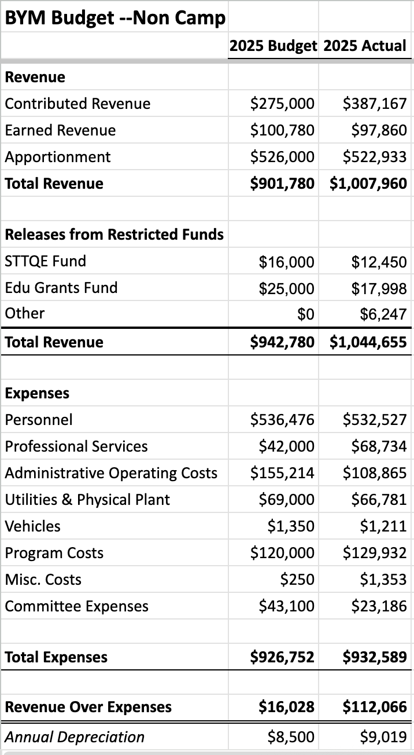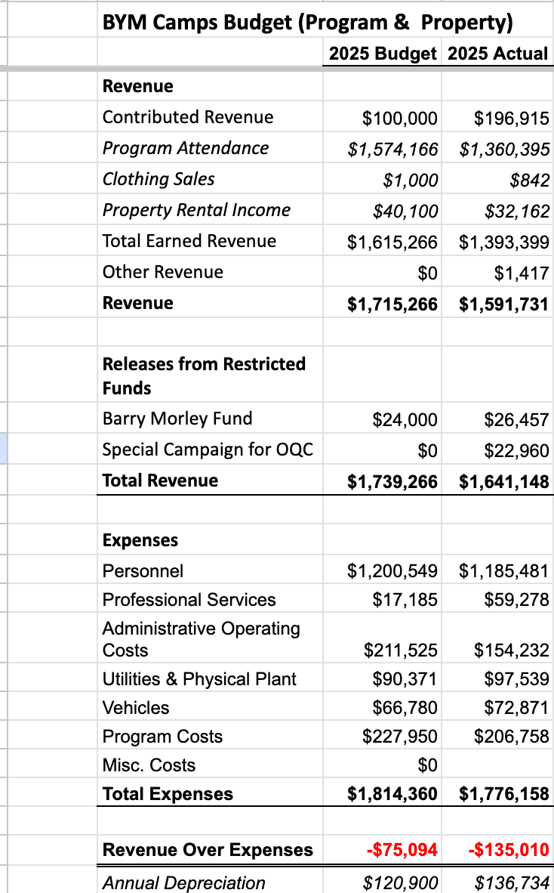
For the Yearly Meeting as a whole
 | 2025 Budget | 2025 Actual
Total Revenue | $2,682,046 | $2,685,803
Total Expenses | $2,741,112 | $2,708747
Revenue Over Expenses | -$59,066 | -$22,944

These operating budget numbers do not include increases in our investment accounts.
Most of our budget estimates were spot on. The surplus in the non camp budget arose mainly from receiving $110,000 more in contributions than expected. The greater than expected deficit in the camping program came mainly from receiving $200,000 less in camp fees than expected. Camp staff has been working aggressively to increase camp enrollment—last year we had nearly 600 campers

Camp Capital Budget

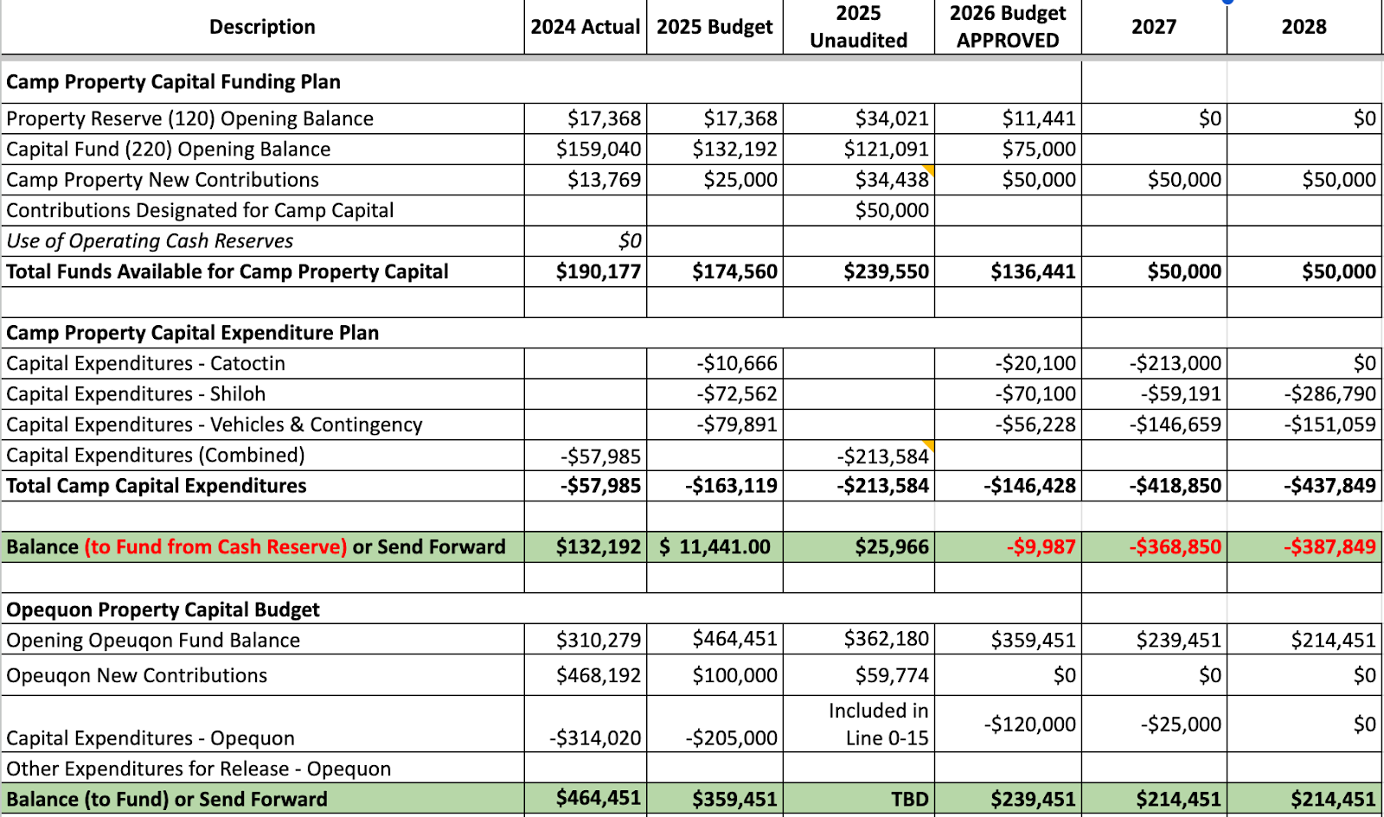
The numbers for the Camp Capital Budget are presented here for information, and especially to highlight the red ink after 2026. We have enough money to operate the camps safely in 2026 but in 2027 and beyond there will be distinct capital needs.
Terence McCormally (Herndon Friends Meeting) Treasurer, Baltimore Yearly Meeting
3/21/26
Attachment I2026-14 (1): Gaza Statement
(available at: https://afsc.org/endorse-gaza-statement)
Dear Friends,
We invite you to read, reflect on, and respond to Quaker organizations discern genocide is occurring in Gaza and urge courageous action. This vital statement follows extensive discernment within and between our eight global Quaker organizations. In a time of grave concern, we came to unity on the need to witness publicly for an end to violence, including the violence of forced starvation, and the resumption of work to build peace and equality in Palestine and Israel.
We ask Friends to consider endorsing our statement. For many meetings and churches this may be an opportunity to engage with integrity in discerning your understanding of our testimonies and your commitment to witness. We rejoice together in the call to faithfulness, continuing in acts of solidarity until genocide ends and peace prevails.
In Spirit,
- American Friends Service Committee
- Canadian Friends Service Committee
- Friends Committee on National Legislation
- Friends World Committee for Consultation World Office
- Quakers in Britain/ Quaker Peace and Social Witness
- Quaker Council on European Affairs
- Quaker Service Norway
- Quaker United Nations Office

A few tools for your discernment

Queries
- How might friends "advocate relentlessly" for the end of suffering, while also centering Palestinian lived experiences? What stands in our way from becoming advocates? What do we need to engage more voices that can join our work for mercy, justice, peace, and freedom?
- In what ways might Quaker communities be unintentionally complicit in how their governments support Israel's military campaigns? What actions will Friends take to divest from Israeli occupation, apartheid, and genocide? How insistent will Friends be in asserting that Palestinian lives matter?
- A key point in this statement is that criticism of Israel's military and government should not be misunderstood as antisemitism. Falsely equating support for Palestinian rights with antisemitism is a tool of propaganda used to obfuscate Israel's responsibility to uphold human rights and adhere to international law. How will Friends show the world that defending the rights, safety, and dignity of Palestinians does not inherently interfere with a commitment among Friends to demonstrate love and compassion for Jewish people?
- Friends have historically identified and publicly denounced state-sanctioned violence ahead of other religious groups. How does speaking out about Israel's violent campaigns against the Palestinian people align with Quaker beliefs and values?
- What role can Quakers play in ensuring the right to protest and free speech is protected in our communities? How can we help protect those who are silenced and harassed? How might we engage with those who feel threatened by passionate voices?

Background information
Following are some resources that may assist Friends in their discernment.
- Convention on the Prevention and Punishment of the Crime of Genocide
- UN explainer: What is the Genocide Convention?
- Yearly Meeting of the Religious Society of Friends (Quakers) in Britain Minute on Gaza, May 2025
- Amnesty International concludes Israel is committing genocide in Gaza
- A Genocide Scholar on the Case Against Israel
- A Textbook Case of Genocide
- United Nations Office for the Coordination of Humanitarian Affairs humanitarian updates
- Updates from AFSC staff
- UNICEF delivers wheelchairs for Gaza's children
- 100,000 Dead: What We Know About Gaza's True Death Toll
- More child amputees in Gaza than anywhere else in the world
Attachment I2026-14 (2): AFSC Apartheid-Free Communities Pledge
In preparation for Baltimore Yearly Meeting’s more in-depth collective consideration of Palestinian human rights needs at the 2026 Annual Session and at the behest of the BYM Palestinian-Israeli Peace and Justice Working Group (PIPJ), the BYM Peace and Social Concerns Committee (BYM PSCC) requests that BYM encourage all of its Monthly meetings to endorse the AFSC Apartheid-Free Communities Pledge, namely:

WE AFFIRM our commitment to freedom , justice, and equality for the Palestinian people and all people;

WE OPPOSE all forms of racism, bigotry, discrimination and oppression, and; ALL WE DECLARE ourselves an apartheid-free community and to that end;

WE PLEDGE to join others in working to end all support to Israel’s apartheid regime, settler colonialism, and military occupation..
So far the BYM PIPJ, BYM PSCC, Bethesda Friends Meeting Peace and Social Concerns Committee, Adelphi Meeting, Annapolis Meeting, Floyd Meeting, Friends Meeting of Washington, and Frederick Meeting are part of 1070 communities who have signed the pledge, including 3 yearly meetings, namely, Iowa, South Central and Canada’s Atlantic half-yearly. It would be amazing if BYM joined this honorable list at its 2026 Annual Session.
We affirm PIPJ’s call for Friends to reflect on the devastating impact of the past two years in Gaza and the ongoing struggle for peace in the region. As Friends, we are called to examine both our spiritual witness and our nation’s complicity in violence through U.S. support for Israeli military operations and the indiscriminate bombing of Gaza.
We grieve the genocide in Gaza and the collective punishment of the Palestinian people. The Israeli Defense Forces’ destruction of entire communities, such as Gaza and the Jenin refugee camp in the West Bank, reflects an alarming pattern of ethnic cleansing that violates international law and the fundamental principles of human dignity.
We also condemn the continuing settler violence in the West Bank and the expansion of settlements. Such aggression and displacement—often carried out with military protection—are unacceptable and illegal according to international law. Peace cannot take root while violence, apartheid, and forced displacement persist. Every person in the region deserves safety, dignity, and the protection of their basic human rights.
We must likewise acknowledge the persistence of systemic racial injustice within our own nation. As Friends committed to peace and equality, we are called to confront both the oppression abroad that our government enables and the injustices at home that mirror these same patterns of domination and exclusion.
Some Meetings have found it helpful to first endorse the Quaker Statement on Genocide, signed by eight national and international Quaker organizations. While this is a valuable step, it is important to note that apartheid is a root cause of violence in the area. It is therefore necessary to speak out against it just as we did for South Africa.
Background Information:
We include with the above request some background and an update from the BYM Palestinian-Israeli Peace and Justice Working Group (PIPJ).
BYM PIPJ was born from the discussions of the August 2024 BYM Minute on Ceasefire in Israel and the Feb. 2025 BYM-PSCC workshop on “Building Collective Power for Peace” led by Adelphi Friends. It was affirmed as a Working Group of the BYM Peace and Social Concerns Committee exactly a year ago.
BYM PIPJ has met monthly on second Wednesdays since then, with representatives from at least fifteen Meetings, and hosted four trainings and talks by AFSC-Apartheid-Free Communities staff members between April and August 2025, and two workshops by Steve Chase of Friends Meeting of Washington, interest groups and film at Annual Meeting 2025–and subsequent workshops at Bethesda, Adelphi and Homewood Meetings. BYM-PIPJ has planned a workshop about the Apartheid Free Communities discernment process at the Networking Day on March 14 and with Richmond-area Friends Meetings soon after. More support for discernment is available by sending an email to bympipj_core@googlegroups.com and resources can be found at the BYM PIPJ drive. An additional resource for BYM congregations is the Apartheid-Free Quaker Affinity Group, which includes over 60 Friends organizations in North America and two in Japan.
We resubmit the request that PIPJ made of the Fall Interim Meeting, mostly unchanged, however we want to acknowledge its exceeding importance after: 1) four months of a “ceasefire” that has killed over 1000 Palestinians; 2) Israeli deregistration of AFSC and many other humanitarian efforts in Gaza; 3) the takeover of many more Gazan and West Bank Palestinian communities (nearly 70% now under Israeli occupation); and 4) the usurping of all UN peace and humanitarian efforts by a Trump-dominated “Peace Council” including Benjamin Netanayahu and Vladimir Putin (and billionaire investors) but no Palestinian representatives. We pray for your study, support and “sumud” (Arabic: persistence) for the very long haul of our collective work for just peace in Israel/Palestine.

Attachment I2026-14 (3): Minute on Harms Caused by the Actions of our Current Government (Shepherdstown Friends Meeting)
The term “Friends of the Truth” was the original name used by members of The Religious Society of Friends (Quakers). Seeking and speaking truth motivates us to create the following statement of our deep concern with the current government’s stark disregard of Constitutional principles and laws, and the harm being done to the people of our country.

We Quakers believe in the inherent value of every person, in fostering peaceful and supportive community relationships, and in equal rights for all. We recognize that the principles and laws laid out in the Constitution of the United States align with many of our deeply held spiritual beliefs: those of liberty and justice for all, fundamental rights, human equality, and opportunity for everyone.
The Constitution states that the President shall take the following oath:

I do solemnly swear (or affirm) that I will faithfully execute the Office of President of the United States, and will to the best of my ability, preserve, protect and defend the Constitution of the United States. (Article II, Section 1)

President Trump has actively failed to honor his oath of office and has thereby caused the following serious harms to the people of the United States:

Harms Caused by the Failure to Protect our First Amendment Rights:
Three of the fundamental freedoms granted by the First Amendment are the freedom of speech, the freedom of the press, and the right of the people to peaceably assemble. Examples of violations of these rights include:
- In an unprecedented encroachment on the freedom of speech in places of learning, the executive branch directs universities on what can be said and taught.
- Language supporting diversity, equity, and inclusion is banned from use in government agencies and educational systems.
- Press with a potentially critical point of view are denied access to press conferences and other sources of information. Support for publicly funded media such as PBS and NPR is withdrawn.
- The freedom to gather for peaceful protests is suppressed by the presence of armed military forces.

Harms From the Failure to Provide Due Process of Law for All People:
The Fourth and Fifth Amendments of the US Constitution provide protections for all people living in the United States. Due process requires that before depriving an individual of “… of life, liberty, or property…” (Fifth Amendment), the government must provide notice of charges, an opportunity to be heard and present a defense, and a decision by an impartial tribunal or neutral decision maker.
Examples of harms caused by the government’s failure to honor due process include:
- Persons targeted by federal agents because of their race or ethnicity are seized and detained without access to representation, resources, or communications with family members. Families are often permanently separated by this practice, and the safety of children is compromised.
- Immigrants and refugees are deported without access to due process of law. Detention centers serve as camps where people endure cruel and inhumane treatment, including physical and psychological deprivation.

Harms From the Failure to Support Equal Rights for All People:
Laws and regulations designed to protect oppressed communities are being dismantled or ignored.
- Organizations such as Planned Parenthood that support women’s and LGBTQ health are defunded, making essential medical treatment harder to access and further increasing disparities in health care.
- The history of America is rewritten so that the complete history of oppressed communities is not told.
- Food (SNAP) and health care programs (Medicaid) are cut, thereby depriving children, the poor and the elderly of basic human services.

Harms Caused by the Failure to Preserve the Constitutional Limitation of ExecutivePowers through a System of Checks and Balances:
Our three branches of government- the executive, judicial, and legislative – are designed to protect our society from authoritarian rule and support a government “of the people, by the people, for the people”. This constitutional system of checks and balances is being undermined by the abuse of executive power. Our democracy is harmed, when, for example:
- Judicial rulings directing the executive branch to cease certain deportations of immigrants are repeatedly disregarded.
- Federal employees are fired without regard to labor laws and union agreements.
- Executive orders abandon years of work promoting international peace, economic development, and humanitarian aid.
- Executive orders defund scientific and medical research approved by Congress, thereby robbing us of scientific knowledge and lifesaving medical advances.
- Cities are occupied by active military and National Guard troops despite laws that forbid military involvement in domestic law enforcement.
We, the members of the Shepherdstown Meeting of the Religious Society of Friends, adopt this statement as our truth about the harm being done to the people of the United States in the name of a president who fails to uphold his oath of office. The United States was founded on the values stated in the Preamble to the Declaration of Independence:

We hold these truths to be self-evident, that all men are created equal, that they are endowed by their Creator with certain unalienable Rights, that among these are Life, Liberty and the pursuit of Happiness.
Without immediate action by the Congress and Judiciary to restore the checks on presidential power, the United States is at risk of losing the constitutional democracy created 250 years ago.
Adopted by the Shepherdstown Friends Meeting, WV, Sept 14, 2025
Endorsed by the Hopewell Centre Monthly Meeting, Winchester, VA, on Dec 14, 2025

An Addendum to the Minute on Harms Caused by the Actions of our Current Government
1. Share the Minute
- With other Friends
- With BYM including the Friday Newsletter
- With AFSC and FCNL
- With meetings in WV, MD, VA, PA, OH, DC
2. Contact other churches and religious organizations
- Contact Church of the Brethren and Mennonite congregations and any others who are known for peace, non-violence and human rights efforts.
- Contact local religious and community organizations who offer support for people suffering harm due to these actions.
- Contact other religious leaders who are active in the resistance movement, including Islamic and Jewish Leaders.
3. Contact and express concern to leaders
Speak out in letters, calls, and protests
- to express our concern about harmful changes to Veterans Administration, Social Security, Medicare, and Medicaid.
- to express opposition to changes in federal taxes that benefit the wealthy over the middle class and poor people
- to support the efforts of the Poor Peoples’ Campaign in WV and DC
- to leaders of agencies that are being illegally altered and pressured to comply with unconstitutional, illegal, and unjust government actions.
- to universities to share our concern about their important role in research that supports all people. Include institutions that Friends have attended or are sending their children to. Ask any local college officials for ways to support them.
- to support elected officials who are standing up to the pressure to comply with illegal and unconstitutional actions.
- to continue and expand our work with FCNL to lobby for change.
4. Endorse, Support, attend and/or organize events.
Endorse, Support, and/or Attend:
- Events led by organizations like the NAACP and Indivisible of Berkeley, Jefferson, and Washington Counties in their efforts to engage citizens in peaceful and non-violent resistance.
- planning meetings for these agencies.
- vigils and protests and share information about
- Quaker values and the work of the local meeting.
- Support and sponsor US history and constitutional law events
Organize:
- another Peace Week (as in 2024) in cooperation with local churches.
- Quaker history educational events
5. Support media organizations, such as PBS and NPR, that focus on publishing the truth
- Write letters of support and make donations to Public Broadcasting organizations.
- Express our concern about their ability to publish the truth in an atmosphere of falsehoods and conspiracy theories.
- Continue to support PBS and NPR as they cover stories of the harms of the current administration.
6. Find ways to work with others to help the current victims of harm.
- Ask local religious and community organizations for ways to participate in helping local victims through their programs.
- Plan to support programs for victims of harm with funds from individuals and the meeting.
7. Continued discernment
- Continue to discuss and discern ways to respond to ongoing and new harms in our region and beyond.
- Plan for a continuation of workshops for Alternatives to Violence.
8. Health and welfare of members and attenders
- Attend yearly and quarterly Meetings
- Attend regional Gatherings
- Form a reading group
- Include music as part of community practice
9. Support and nurture Young Friends
- Address Quaker values in First Day School
- Support Quaker Camp for Young Friends

