Pueblo Adventures—Exploring New Mexico’s Indigenous Cultures

Sue Marcus
“Let’s go to New Mexico!” A Canadian friend, living in Florida, wanted to experience some of Indian Country and asked me to be her guide. I was honored to do so, and off we went in April. We started planning in January, learning that the Gathering of Nations (world’s biggest pow wow) would happen while we were in Albuquerque. We got tickets and then learned it would be the last Gathering—the family that ran it had aged out.
We started our trip in Albuquerque on April 22, 2026 with a visit to the Indian Pueblo Cultural
Center. When in Albuquerque, you must go! It is a one-stop place to learn about the 19
Indigenous Pueblos in New Mexico. There are exhibits of the diverse pottery styles and how they evolved through time. The history of the Indigenous and Spanish relationship is also told. We were lucky enough to visit on a day when the dance groups from several Pueblos performed and Native artists sold their crafts, ranging from beadwork to horsehair pottery to exquisite jewelry and sculptures.
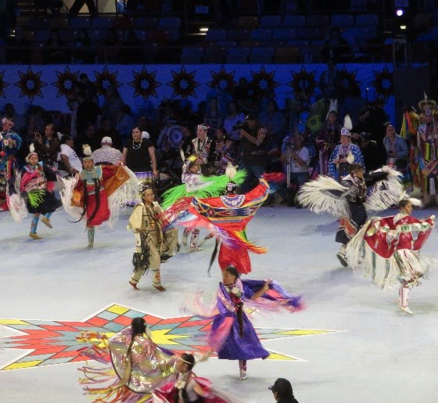
The Gathering was big—more than 100,000 people attended during the 2-day event with more than 3,000 dancers and singers. We found seats in the indoor arena and watched the competitive dancing for a couple of hours. There were more than 300 vendors. At the Gathering, we watched a “special” dance. These are competitive dances sponsored by someone. It this case, it was a Native guy who had been an engineer. To give back and to honor his family, he gave prizes of $2,000 for the top dancers in that special dance, $1,000 to the top dancer, and $500 each to the next 2 runners up. He’s just an ordinary person, like you or me. Would we give away
Dancers at the Gathering of Nations. money like that? He brought joy and honor to many Photo by Sue Marcus people, including himself and his family.
Another must, if you’re in Albuquerque, is to visit Sky City, the traditional Acoma Pueblo atop a mesa. It has existed there for more than 800 years. A few families still live there and more have a family home they use on ceremonial days. Crafters sell their work on tables outside their adobe homes. Some also sell fry bread, fresh from the fryer! The Spanish conquered and enslaved the Acoma people, forcing them to build a church that is still maintained.
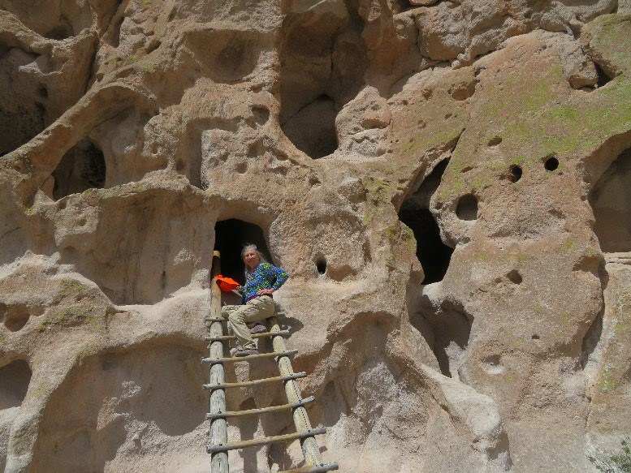
From Acoma, we drove to the Zuni Pueblo, browsing the shops there. The Zuni are noted for their inlaid jewelry. We stayed at a small, funky hotel—with different grades of raw turquoise for sale in a case in an office/general store/ storage area. Next, it was on to Bandelier National Monument to see some of the cliff or cave dwellings of the ancestral Puebloans. Many of the larger structures have been reconstructed. This is a large site, with places where visitors can climb ladders to see some of the dwelling that were carved out of the cliff faces. Kivas (ceremonial structures still used in most Pueblos today) and petroglyphs are features of this place.
Along the way to Sante Fe, we stopped at the Jemez Pueblo’s Walatowa History Museum. This small, excellent museum explains the history and culture of the tribe. A heartwarming feature is an extensive photo display of Jemez kids with each poster telling the story of the child learning part of her or his culture—a specific dance, or food gathering method, sharing oral
histories, participating in ceremonies, and
Sue Marcus explores the Bandolier National much more. It personalized the cultural
Monument
traditions.
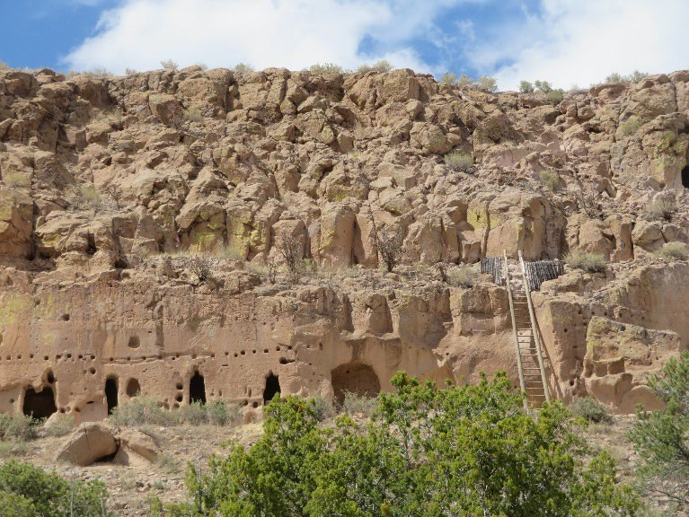
My favorite place on the trip was one I didn’t get to fully explore. Basing ourselves near Santa Fe, we visited the Puye cliff dwellings on the Santa Clara Pueblo. The Puye site includes multistory cliff dwellings as far as I could see. We arrived on half an hour before they closed, so the tours had ended for the day. I happily chatted with the ranger in the small museum. He’s a member of the Santa Clara Pueblo, had been tribal Administrator and, as a natural resource specialist, he had worked with my former agency, the U.S. Geological Survey.
When I mentioned that the Gathering would no longer be held, he and another person on our trip noted that powwows are not a tradition for the Pueblo people. Their dances are for ceremonies and celebrations. People usually only dance their own traditional dances, unlike the shared styles of dancing at pow wows
(jingle, northern traditional, fancy, etc.). A teachable moment. I want to go back to the Puye cliff dwellings!
The Puye Cliff Dwellings. Photograph by Sue My friend and I both like Santa Clara Marcus. pottery, so I tried to find some place on the Pueblo where we might buy a piece. We contacted a potter who invited us to her home. She does gorgeous work and has won many awards. The $700 price of a piece I really liked was, unfortunately, above my price range. She does everything from gathering the different types of clay she uses to making her glazes and etching some pots with sharp blade. She’s a grandma raising her grandkids—with triplets on the way! I bought a small animal made from the leftover bits of clay. She wastes nothing. It was an unexpected honor to be able to visit a potter at home.
You can find examples of Santa Clara Pottery and other Pueblo crafts for sale here: https://www.pueblodirect.com/
We returned to Albuquerque, where I always visit Rio Grande Trading. They buy directly from the artisans and have pottery and other items for every pocketbook. I explained to my friend that I bought-Native made items, preferably directly from the artists, as a way to show support. They do this for a living. Many people sell souvenirs that they claim are made by Natives, but in fact may be made in China or elsewhere. One good source of information on authentic Native crafts is provided by the Department of the Interior. Here it is: https://www.doi.gov/iacb/iacbpublications
Exploring Native American sites is a wonderful way to learn, and many of them offer guided tours by indigenous guides. The National Park Service offers a list of possible places open for public visits that are important to indigenous people of the United States. Find it here:
https://www.nps.gov/articles/visit-indigenous-landscapes.htm Hmmm…where would you like to go – ?

