IAQ : Indigenous Affairs Quarterly
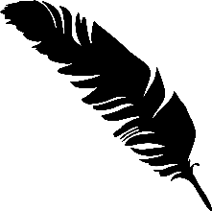
Baltimore Yearly Meeting Indigenous Affairs Committee Summer, 2026
If no one else is distributing the IAQ to your meeting – tag, you’re it! Please share it! You may forward it to your listserv, print copies to share, or whatever works. This IAQ and all the other editions are posted on the Indigenous Affairs Committee's website. Here is the shortened link to get you there: https://bit.ly/3Ks8b8x

In the News
Recently President Trump slashed protections for two sites – Bears Ears and Grand StaircaseEscalante National Monuments – that have long been regarded as sacred by the Navajo Nation,
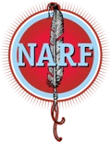
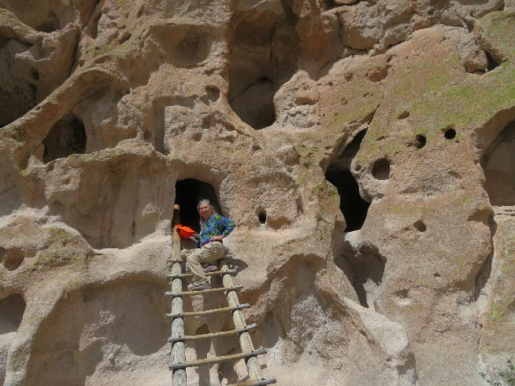
Hopi Tribe, Pueblo of Zuni, Ute Indian Tribe, and Ute Mountain Ute Tribe. Native News Online (7/20) tells us that these sites contain “thousands of archaeological and cultural sites, including cliff dwellings, rock art, ceremonial locations, and ancestral villages. Tribal citizens also continue to hunt, gather medicinal plants, and conduct traditional cultural practices throughout the landscape.” Trump’s proclamation reduces each monument by about 90% and opens them both up to oil and gas drilling.

Natives will be challenging his right to do so in court. Native American Rights Fund (NARF) Deputy Director Matthew Campbell says, “ Tribal Nations have protected these lands for generations and they won’t stop now.” Since this is not a legislative issue, one of the best ways to support Native Americans in the legal battle may be to send a donation to NARF, a 501 (c) (3)
organization with a four-star rating from Charity Navigator. Learn more about NARF from their
website: https://narf.org/

What We’re Learning
Travelling to Tribal lands and meeting Native American crafters and guides is a wonderful way to learn about indigenous peoples. Sue Marcus, Sue Marcus explores the Bandolier National a former member of the IAC who is still Monument in New Mexico, once a dwelling committed to learning and advocacy on behalf for indigenous people.
of Tribes, recently travelled to New Mexico to
explore some of its many Pueblos, each with its own history and Tribal identity. Check out Sue’s report, Pueblo Adventures—Exploring New Mexico’s Indigenous Cultures, on the IAC website.
The National Park Service offers a list of possible places open for public visits that are important to indigenous people of the United States. Find it here: https://www.nps.gov/articles/visitindigenous-landscapes.htm

Resources
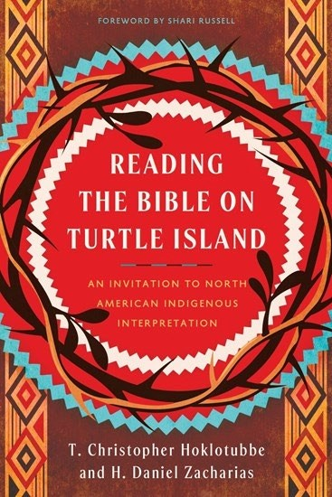
If the Bible is a source of inspiration for you – or if you’d like to encounter it again from a whole fresh perspective – check out Reading the Bible on Turtle Island. The authors, T. Christopher Hoklotubbe and H. Daniel Zacharias, are Natives who are also theologians. They approach the Bible with a deep respect for Tribal traditions and find not conflict, but consistency. Although Christians historically have treated Native wisdom and ceremonies as heathen heresy to be stamped out, these theologians find in their traditions a kind of “old Testament” that meshes with and enlightens Biblical stories and teachings. A fresh reading of Genesis stresses our kinship with all creation, while Jesus’s teachings and life – including his “vision quest” in the desert – are a call to harmony that speaks to Indigenous peoples. Readers are shown where Natives can find themselves and their ancestors in Scripture – arguably more easily than many Christians of European descent. The book is beautifully written and a joy to read. Plug the title into your search engine and you’ll find multiple sources.

Tending Our Roots is a conversation-based podcast that uplifts Indigenous voices, knowledge, and ways of being as pathways to well-being. Hosted by Dr. Miigis Gonzalez (Lac Courte Oreilles Ojibwe) and Dr. Jill Fish (lineal descendant of the Tuscarora Nation), the podcast creates space for stories grounded in relationships—to land, to community, to spirit, and to self. Each episode brings listeners into conversation with guests whose lives and work reflect Indigenous approaches to living well Listen to this week's episode here:
https://cih.jhu.edu/programs/tending-our-roots/

Special Events
The National Museum of the American Indian, located in Washington, D.C., offers an exhibit of
100 years of Indigenous art. Stretching the Canvas, Ten Decades of Native Painting, explores “how Native artists challenged perceptions of what constituted art and what Native art could and should look like. Featuring more than 50 works by over 40 artists, this exhibition tells the story of how American Indian art expanded after World War I and how Native painters began to advocate for themselves in a world that often ignored their talent….Over the span of ten decades, these artists and their work demonstrated the breadth, complexity, and continuing expansion of Native self-expression.” For more information, go to: https://americanindian.si.edu/explore/exhibitions/item?id=1017

Summer is a great time to go to powwows – and take the children, these are great family outings! You can find powwows near you at powwows.com. Check out:
https://www.powwows.com/pow-wows-in-my-state

Opportunities to Partner
The BYM Indigenous Affairs Committee has an invitation especially for Virginia
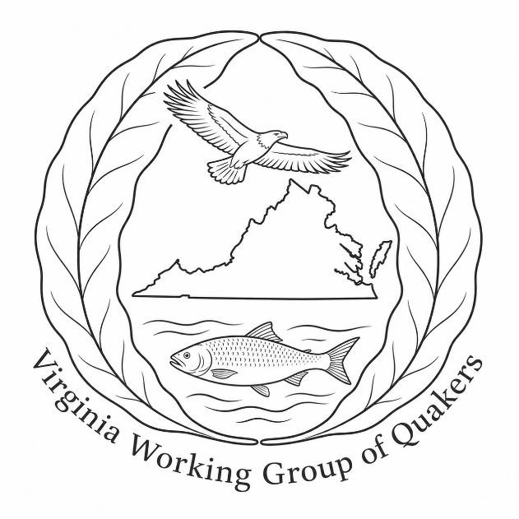
Quakers. We are establishing a Working Group under the leadership of our new committee clerk, Abbey Compton, to collaborate in building meaningful, ongoing relationships with Tribal leaders and elders across the Commonwealth. We will listen to their concerns and advocate for them as we are led by Spirit. For more information or to receive a form expressing your interest, email abbeycomptonishere@gmail.com. No expertise is needed.

The Pocahantas Project, based in Virginia, is an enthusiastic sponsor of initiatives to declare an Indigenous Peoples Day in states or cities. So far, Maryland, Virginia, West Virginia, and Pennsylvania have not joined other states in this movement. Click on “Get Involved” and lend your support: https://www.pocahontasproject.org/ipd-initiative

