Baltimore Yearly Meeting Indigenous Affairs Committee Annual Report
July, 2025

Travel to Pawnee, Oklahoma to Convey Reparations Funds

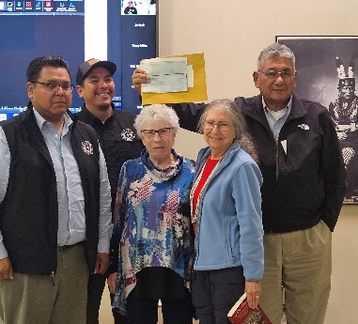
At annual session in 2024, Baltimore Yearly Meeting approved financial reparations to the Pawnee people for our involvement in activities that were destructive of Pawnee culture, including running a school. We agreed to send $10,000 in 2024 and $10,000 in 2025. Our offer was warmly received and we expect that the funds will be used to support a language restoration project by the Tribe or other projects that revive the Pawnee’s cultural heritage.

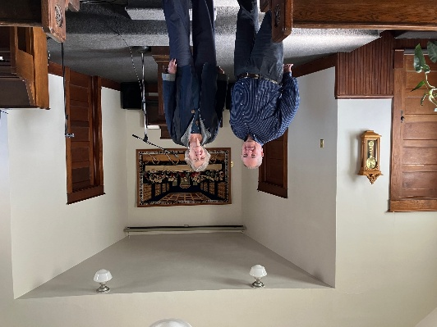
In November of 2024 Patricia Powers, Susannah Rose, and Sue Marcus travelled to Pawnee, Oklahoma. We were invited to the Tribe’s Veterans Day ceremony, a feast in which veterans were individually named and honored, by Herb Adson, Cultural Director for the Pawnee Nation. We spoke briefly at the celebration to explain our presence and were received with hospitality. Patricia and Sue explained the history of Quakers and Pawnees to a Pawnee language class the next day and presented the $10,000 check, as well as an additional check from Alexandria Friends Meeting for $1,000. The second check for $10,000 (for 2025) was delivered by mail in June 2025 and was especially welcome due to the devastating cuts this administration has inflicted on Tribes.
Pat Powers and Sue Marcus present reparations check on behalf of BYM. Left to right: Gilbert Beard, Chief of Skiri Band; Taylor Moore, language teacher; Pat; Sue; and Herb Adson

An additional bonus from the November 2024 visit was the opportunity to connect with a long-time Quaker pastor nearby. Susannah and Sue met with David Nagle in Hominy, Oklahoma. Hominy Friends Church is the Quaker meeting closest to the Pawnee lands. (It is part of Great Plains Yearly Meeting.) The Hominy Meeting members are mostly members of the Osage Nation or related to Osage members. The Meeting has been involved with the Osage people since 1908. We were inspired by David’s efforts to honor Osage language and customs, including learning Osage himself and incorporating it in his services. In part thanks to his efforts, a school focusing on indigenous language and tradition is now available to Osage youth.
Susannah Rose and David Nagle in the Quaker church

Presentation by Indigenous Leader

At the 2024 Annual Session, IAC sponsored a plenary session by Chief Dennis J. Coker, who has served as the Principal Chief of the Lenape Indian Tribe of Delaware since 1996. (See: http://lenapeindiantribeofdelaware.com/.) Chief Coker described the Tribe’s determined efforts to revitalize land donated to the tribe that had been polluted and overrun by non-native plants. The Tribe and volunteers wanted to provide a model of land recovery, and we were inspired by their efforts.
Activities and Projects

Committee Continuity

Since many experienced committee members rotated off the committee at the same time, leaving mostly new members with a lot to learn, Co-Clerks interviewed key members individually and documented important history, resources, and contacts. Pat Powers, Dellie James, and Dan Cole also met with the committee as a whole and provided background. All three provided files related to the committee’s history, which have been organized for easy transmission in the future. New members have been striving to learn.

Information Dissemination

The IAC continues to publish the Indigenous Affairs Quarterly (IAQ). The quarterly features news, resources, historical information, and upcoming events. It is sent to identified contacts at Monthly Meetings and others who have expressed interest. All editions are posted on the committee’s website, with a link to the latest issue included in BYM’s newsletter. The editor is Susannah Rose. If you want to be put on the email list, contact her at susanhillsrose@gmail.com.

Data Update Report

Our committee received BYM funding for a project to update a comprehensive 2009 report issued by FCNL that captures essential demographic and other information about Native Americans. Among the topics are facts about Native health, education, housing, employment and infrastructure.
To complete the update, we engaged the services of Alexis Contreras, a member of the Confederated Tribes of the Grand Ronde Community. Ms. Contreras is acquired her experience as a researcher at the National Indian Child Welfare Association. She submitted a first draft and recently submitted a revised draft in which she addressed extensive comments and suggestions from the committee, including the need to include Native Alaskans and Native Hawaiians to the extent possible. These populations were not included in the original FCNL document. The IAC is in the process of reviewing the document and will consult with Ms. Contreras about the most effective way to make its findings available.
Attendance at National Conference
Bill Mims attended the National Congress of American Indians in February and reported on many powerful presentations, including the annual Native State of the Union and moving speeches by two young Indians about their hopes for their people.

Liaison with Outside Organizations
FCNL

IAC invited FCNL’s Native American Advocate, Rachel Overstreet, to give a presentation to the committee on legislation needed to address Native American issues. A current priority is passing the Truth and Healing Commission Bill on Indian Boarding School policies, which was approved by the Senate unanimously in the last session but did not receive a vote in the House of Representatives.

Future legislation is needed to address the crisis of missing and murdered indigenous women. This will be the primary focus of a workshop by Ms. Overstreet at Annual Session 2025, sponsored by the IAC.

Liaison with other organizations has not been a priority this year as our new members sought to grow in their knowledge and discern directions. We hope to do better next year!

Composition of Committee

Members for 2024-25 include Susannah Rose and Steve Tatum (Co-Clerks), Sharon Stout, Bill Mims, Abbey Compton, John Meyer, Eric Nelson, Betty Smallwood, Stuart Green, and Darcy Lane. Dan Cole has served as a co-opted member and will rejoin the committee in 2025-26. Darcy Lane will not be continuing on the committee and Eric Nelson is currently inactive.

