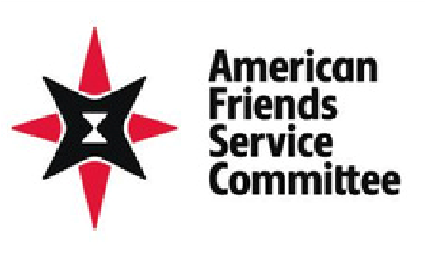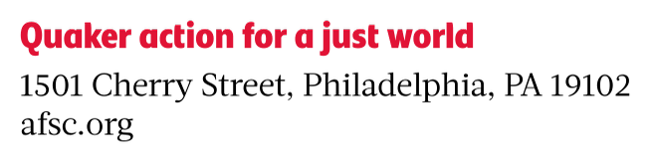
Dear Friends Everywhere, March 2026
Perhaps now more than ever, the world needs the action and witness of Quakers to resist the rising tides of authoritarianism, war, and injustice -- from the systematic atrocities in Palestine to the unconscionable war on Iran, the machinery of armed conflict—fueled by corporations who profit from war—is claiming countless lives and shattering communities before our eyes. Communities who suffer from the impacts of settler-colonialism, racism, misogyny, xenophobia, and unimpeded capitalism are calling upon Friends to act in solidarity for peace, justice, and dignity for all. The American Friends Service Committee (AFSC) is answering that call with urgency. We are proud to partner with Quaker communities worldwide to resist the horrors of war and build a just peace.
At AFSC, we assert the equality, worth, and dignity of all people and regard no one as our enemy. We demonstrate the transformative power of love and active nonviolence as a force for justice and reconciliation, and we trust the Spirit to guide our discernment about how to take action. As we step further into 2026, we invite Friends to explore opportunities to speak truth to power and show what love can do by getting involved in one or more of our programs and campaigns.
This epistle briefly describes the annual meeting of the AFSC Corporation and offers a few highlights from our work. Far from comprehensive, we hope this epistle helps build awareness among Friends about AFSC’s presence in the world and provides a window into some of the opportunities for Friends to partner with AFSC.

The Annual Meeting of the AFSC Corporation
The theme for this year’s annual meeting of the AFSC Corporation is “Spirit-Led Activism for Our Suffering World.” While many approaches to social change exist, Spirit-led activism is distinctive as it is rooted in nonviolence, emerging from collective discernment, and resulting in selfless service to communities facing violence. At the meeting, the Corporation reinvigorates AFSC’s commitments to Spirit-led activism. We practice Spirit-led activism because a suffering world needs it—for healing, redemption, reconciliation, and the building of the beloved community.

Stronger with Immigrants
Immigrants make our communities stronger. They are our family members, friends, neighbors, coworkers, and vital members of our communities. But since taking office, the Trump administration has detained and deported hundreds of thousands of immigrants, carried out violent raids nationwide, and created a culture of fear.
Today, AFSC is working to address the economic and political drivers of migration, to ensure that migrant communities are safe and protected, and support migrants, refugees, and internally displaced people at each stage of their journey. We are responding to ICE raids, offering support to community members with loved ones in detention, providing free legal representation, advocating for people’s release, monitoring human rights violations along the U.S.-Mexico border, and educating immigrants and allies through Know Your Rights trainings.
As part of our Stronger with Immigrants campaign, we are asking Friends to tell Congress and the Trump administration to immediately halt detention and deportation and insist that they support policies that treat all people with dignity and respect. Donations to our Stronger with Immigrants campaign support our ongoing immigrant rights work, including our legal services, advocacy, and organizing. We are also encouraging Quaker communities to bring “Our Communities are Stronger // Los Inmigrantes Hacen Nuestras Comunidades Mas Fuertes” signs to actions and place a yardsign version of this message in front of your church, meetinghouse, homes, and offices.
This spring, AFSC is convening a Quaker Action for Migration Justice Network (QAMJN) to coordinate
Friends witness in opposition to cruel immigration policies and violent enforcement. This network of Quaker congregations will host monthly online gatherings where Friends may discern and implement collective action. As part of its Spiritual Infrastructure of the Future program, the American Council of Learned Societies is sending a Ph.D. student to help AFSC build and support QAMJN over nine weeks during the summer months. Interested churches and meetings can write to friends@afsc.org to get involved in the network.
The Humanitarian Crisis in Gaza and AFSC’s U.S.-based Palestine Activism
Since the start of the genocide in Gaza in 2023, AFSC staff in Gaza have provided food, water, hygiene kits, baby formula and other lifesaving assistance to over 1 million displaced Palestinians. We have also provided educational activities for over 4,000 children.
In March of 2025, Israel passed new and extremely restrictive registration requirements for international organizations. These requirements impose prohibitively difficult reporting requirements and require organizations to submit complete staff lists and other sensitive information about staff and their families to the Israeli government. Israel’s occupation in the Palestinian territory is unlawful. Disclosing operational information to a government credibly accused of genocide and apartheid endangers
the lives of our staff and partners, and for these reasons AFSC made the difficult decision to not reapply for registration with the Israeli government. Regardless, our work in Gaza and across the occupied Palestinian territory will continue. Our commitment to this work is unwavering, and we believe unflinching solidarity with the Palestinian people is needed now more than ever. AFSC will be able to continue operating in Gaza because our model of working with local staff and partners allows us to adapt to changing restrictions, making AFSC distinct from organizations that rely primarily on bringing in foreign staff and aid trucks.
In 2023, AFSC created the Apartheid-Free Communities Coalition, an interfaith network of congregations that have dedicated themselves toward taking action to dismantle Israeli apartheid. AFSC is celebrating over 1,000 communities who have joined the coalition, including over 60 Quaker communities. In December 2025, representatives from Quaker communities in the United States and Canada formed the Apartheid-Free Quaker Affinity Group (QAG). They meet monthly to discern and implement collective action. This year, QAG is working to amplify Quaker witness against apartheid and convince political leaders in the U.S. to leverage their power to restore the rights of the Palestinian people. To learn more, visit the QAG website. If your Quaker meeting or church has not already done so, consider joining the Apartheid-Free Coalition.

Climate Justice and Food Justice
The climate crisis disproportionately harms low-income, working-class, Indigenous, Black and Brown people, and other marginalized communities worldwide. Wealthy countries, militaries, corporations, and individuals have profited from high carbon emissions and overconsumption of the earth’s resources, and we urge these actors to accept responsibility.
From New Mexico to Kenya to Guatemala to Jordan, AFSC is working to protect community water rights, support migrants affected by climate change, and help farmers achieve food sovereignty. Our continuing partnerships through the Quaker United Nations Office have also supported our efforts to build important alliances, highlight the urgency of the climate crisis, and accelerate impact for the most marginalized populations. And we are forming new partnerships with other Quaker organizations, such as Earth Quaker Action Team (EQAT) and Quaker Earthcare Witness (QEW), in developing our global campaigns relating to fossil fuel production and investments.
One way Friends can get involved in AFSC’s food justice work is to join our No Hunger Summer campaign. We are calling Friends to help urge state governors to accept freely available federal funds designated by Congress to feed school-age children in low-income families over the summer. In 2024, Congress created the SUN Bucks program, which provides $120 in grocery-buying benefits to lowincome families with school-age children. This program could benefit as many as 30 million children. While most states opted in, 11 states have not yet implemented the program. Those states include Alaska, Florida, Georgia, Idaho, Mississippi, Oklahoma, South Carolina, South Dakota, Texas, Tennessee, and Wyoming. If you live in one of these states, join our No Hunger Summer campaign and urge your governor to act.
More Ways to Get Involved . . .
Our Emerging Leaders for Liberation program, now in its fifth year, equips young adult
changemakers with the skills they need to effectively enact social change. We encourage young adult Friends ages 18-22 to apply for this program so they can learn effective organizing and advocacy strategies from AFSC staff. Applications for the next cohort will open in Feb. 2027.
Anyone can learn from the esteemed social change leaders on our staff by joining our Protect, Resist, and Build webinars, hosted every third Tuesday of the month at 8 p.m. ET / 5 p.m. PT. And please join us for Meeting for Worship with Attention to Peace every Thursday at 7:30 p.m. ET / 4:30 p.m. PT.
We encourage Friends to sign up for our weekly newsletter called “Weekend Reading” and our monthly “Acting in Faith” newsletter, specifically tailored for Friends, for the latest updates about AFSC’s work and how you can get involved. More information can also be found at https://afsc.org/friends-engage.
There are so many ways for Friends to partner with AFSC towards creating a more just, sustainable, and peaceful world. Our staff will be visiting over 20 Yearly Meetings this year and over 80 events at Quaker meetings, churches, schools, and retirement communities. You can submit a request for a speaker to attend your meeting here.
In 1949, Howard Thurman wrote: “They are the poor, the disinherited, the dispossessed. What does our religion say to them?” Over 70 years later, AFSC continues to generate responses to this question and exercise Quaker values in our work.

