Staff Report of the Camp Property Manager to Baltimore Yearly Meeting
David Hunter
November 2022

It has been an active year at the BYM camp properties! Some planned projects were completed and several projects came up that we had not anticipated. Nevertheless we were able to prepare a save and comfortable space for our camps this summer and engage some other exciting opportunities as well.

Off Season Rentals
Camp rentals at Catoctin are going wonderfully! We continue to rent the converted infirmary on AirBnB. The cabin is rented every weekend which it is available and often on weekdays as well. Our guests often comment that they appreciate the rest and renewal the woods at Catoctin provide.
We continue to rent 8 of the 12 camper cabins at Catoctin on HipCamp (similar to AirBnB but for folks looking for a more rustic camping experiences). We have been begun listing the lodge/kitchen/dining hall as one of the facilities available as well. This has encouraged some of the Meetings and Friend Schools that have used Camp in the past to book the entire camp for their use. If you're meeting, family or other gathering would like to take advantage of this possibility please let us know. We have coupon codes for those associated with Baltimore Yearly Meeting that offer substantial discount.
We look forward to the time when we can take better advantage of the facilities at Shiloh to generate off-season revenue as well. For this to be a possibility we will need more help: either on site at Shiloh or more administrative help in the office.

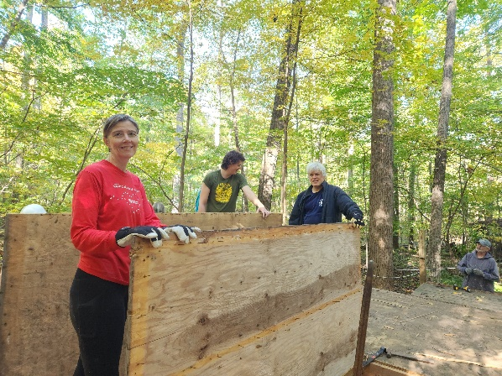
Work days
Several volunteers gathered at each of the properties this spring to get ready for another super camping season. Cabins were furnished, repaired and cleaned, paths were cleared and bathhouses and kitchens were cleaned. When all the dust cleared we were ready for the camping program staff to arrive and start preparing for another fabulous season of camping.
Unfortunately, the fall work days have been a little more challenging. It was necessary to cancel the workdays at Shiloh and Opequon due to low registration and the remaining dates could use some more participants as well.
We did have a good group of volunteers come out on October 10th and 21st to tear down and remove the last cabin that needs replacing at Catoctin. It is nice to be close to the end of replacing the cabins at two of our camps! We will have another workday to shut down Catoctin on October 29th and would love to have several more folks sign up to help!
This year we have an additional exciting opportunity to leave our mark on the properties that are home to our camps. BYM received a grant to plant 100 American Chestnuts this summer and we will be hosting 2 Chestnut Restoration days at Catoctin on November 6th and 12th to start planting blight resistant American Chestnuts (see the Catoctin section below). We will have more Chestnut Restoration days in early April 2023.
Before we move on I would like to point out that canceling workdays means more work for the Camp Property Manager and the Camp Caretakers involved. There are jobs that we would normally get done each year that cannot be done by one or two people. In short it means that that we are not able to practice the high level of stewardship at our camps that our properties deserve. If we cannot take good care of the properties now we know that the properties will require more of our resources in the future.

Catoctin
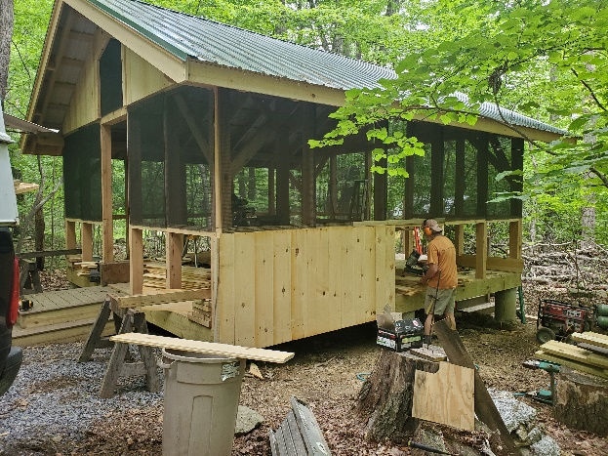
Several exciting projects were accomplished at Catoctin this year. First, we were able to complete a new camper cabin in the nick-of-time for the 2022 camping season. Peter Bugler was able to complete another post and beam work of art. Each of his cabins have edged towards perfection and we are eager to see how his final camper cabin turns out. We have one more cabin to complete this fall and we will have replaced all of the camper cabins at Catoctin, a project that only took 19 years!
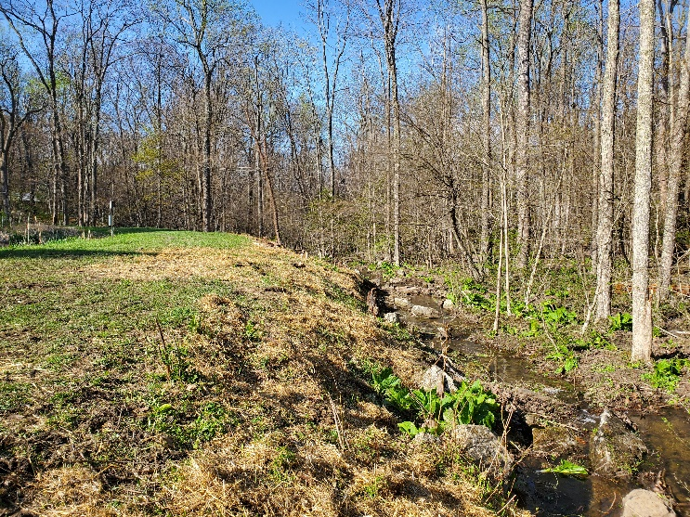
We were also able to complete a pond bank restoration project on the banks of the Catoctin Lagoon. If woody plants are allowed to grow on pond banks the growth and dying back of the woody root system eventually creates leaks in even the best made dams. This year we removed small trees and invasive species from the banks of the pond and replace them with a conservation seed blend of meadow mix, several varieties of native grasses and ferns. Black eyed Susan's and sweet clover are already gracing the banks of our dam. We look forward to seeing what other forbs and grasses emerge in the years to come.
We have been anticipating the need to replace the roof on the craft shelter for the last few years. This summer leaks began to emerge and we knew it was time. Due to the crazy construction materials market, we were able to spend a few extra dollars and install a long lasting steel roof instead of the asphalt shingle roof we had planned on.

The Year to Come
We are looking forward to replacing the very last camper cabin at Catoctin in the fall of 2022. Several smaller projects need to be tackled as well.
We have been looking forward to replacing the tiles in the lodge and kitchen for several years now and we are determined to get this done in the year to come. However, it makes sense to take on a few other renovations before the tiles are replaced. The bathroom in the lodge is in dire need of renovation and several of the walls in the lodge need to be better secured. We hope to find a contractor to accomplish all 3 of these projects by spring of 2023.
We will continue to keep an eye on the aging dining hall roof to make sure that it gets re-shingled before any water damage occurs.

The Health Care Center
One thing that the pandemic has made clear is the existence of some inadequacies of our health healthcare facilities at the camps. We have made several modifications at all the camps to help cope with the presence of covid 19 among us. We have also found several other issues that need to be addressed to help us cope with the ongoing pandemic as well as other challenges we'll face in the future.
The infirmary at Catoctin was built over 50 years ago and the structure is beginning to show its age. Rather than making the investment in modifying that building we feel it will make more sense to build a new healthcare facility and repurposing the existing structure. The Camp Property Management Committee will we'll be working on a design for a new building to serve as health center built on the site of the old Barr's Den. Our intention is to design the building with healthcare facility criteria first in our minds. However, we also want to design the building so that it can serve other purposes as well. These purposes would include off-season rentals that would help generate additionalneeded revenue.

Chestnut Restoration
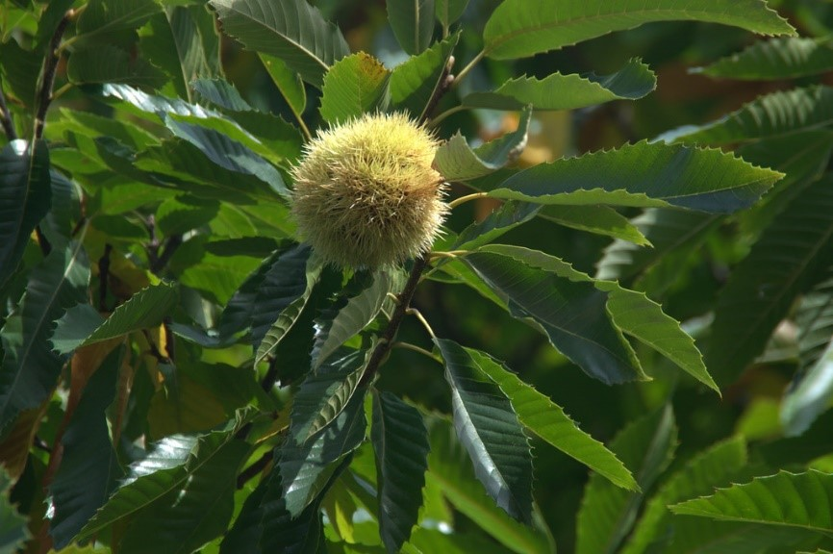
The American Chestnut is now functionally extinct, but it once dominated the forest from Maine to Georgia and west to the Mississippi River. Forests that contained American Chestnuts offered 5 times as much food for people and wildlife as other forests, supplied us with abundant high quality lumber, increased the forest ability to capture carbon from the atmosphere and build rich soils as well as many other ecological and economic services. In the late 1800 a blight was introduced from overseas and by 1900 the American Chestnut was functionally extinct. The American Chestnut Foundation has been hard at work for nearly 40 years and is creating cultivars of the American Chestnut that demonstrate good resistance to the blight and many od us feel it is time to begin reintroducing them to the eastern forests.
We believe it is time for the American Chestnut to return to the Catoctin mountains! Fortunately so does the Robert F. Schumann Foundation which has agree to fund the planting of 100 American Chestnuts at Catoctin Quaker Camp. The seedlings will be generously provided by several chapters of the American Chestnut Foundation and the first 34 trees will be planted in the fall of 2022.
Are you ready to be a part of history? Would you like to be a part of beginning to heal one of the most devastating ecological blows the forests of eastern North America have suffered? Well than come and join us for the Chestnut Restoration Days at Catoctin Quaker Camp this fall! We are planning on beginning to plant on November 6th and will continue, if necessary, on November 12th.

Opequon
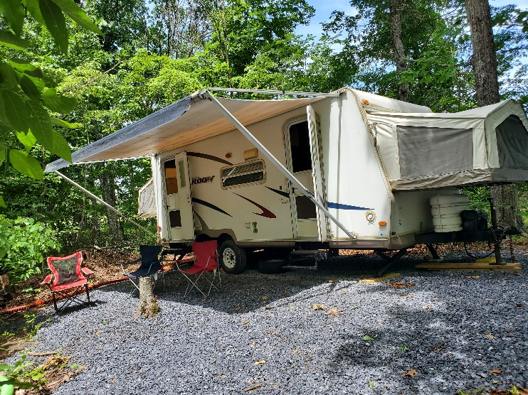
This year at Opequon we were facing some challenges in housing our director and his family. We decided that the most efficient solution might be to purchase a used camper trailer to be set up at Opequon. We were able to create a nice space for the trailer with water, septic and electrical hook ups and it seems clear that Jared Wood and his boys enjoyed it immensely.
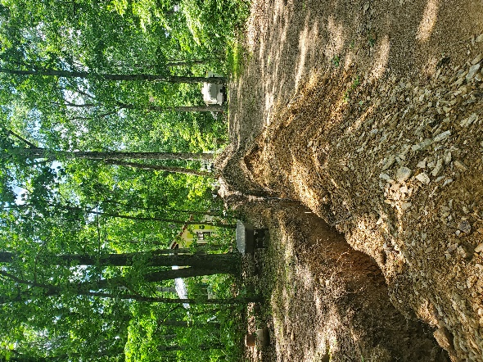
While working on building the camper trailer site this spring we uncovered some problems with the electrical service at that end of the camp. In the end, it was necessary to replace some of the buried electrical lines that supply the bathhouse, shower trailer and the new camper site. The work was completed in time for pre-camp to begin.

Rolling Ridge Conservancy
As many friends will remember, we have been looking for a new location for the program at Opequon for several years. Our lease at Opequon is coming to an end and several problems with the site have surfaced over the years. The driveway is prone to flooding, the site is a little small, there is no longer an adequate place to swim and many of the improvements that we anticipate needing to make in the years to come will be expensive. We suspect that friends will be hesitant to invest more heavily in a property which is not secure in the long term.
A joint sub-committee of the Camp Property Management Committee and the Camping Program Committee Has looked at several properties over the last 4 or 5 years and found that purchasing a new property would cost in the neighborhood of one million dollars.
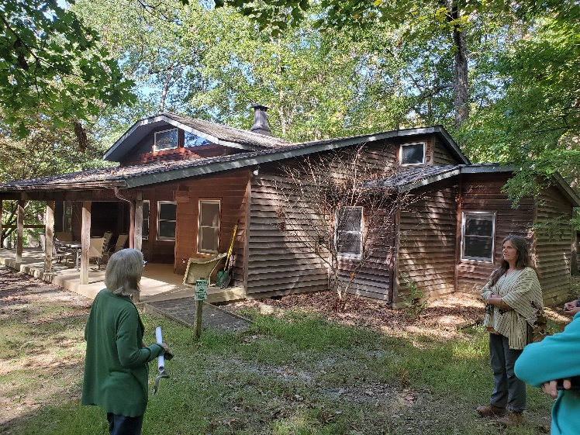
Fortunately another possibility has emerged! In the 1970s a family of Friends from Baltimore started a foundation near Harper's Ferry West Virginia which is now known as the Rolling Ridge Conservancy. Rolling Ridge is steward to over 1600 acres of land which sits between the Appalachian Trail and the Shenandoah River. At Rolling Ridge three organizations have partnered to fulfill the mission of the conservancy. Friends Wilderness Center offers Quakers and others an opportunity to renew their Spirits and learn about the connections between the natural world and the life of the Spirit in a beautiful wilderness setting. They offer hospitality, classes related to conservation and ecology and opportunities for spiritual enrichment. Rolling Ridge Study Retreat offers individuals an opportunity to live in an intentional community, surrounded by nature and dedicated to exploring the connections between spirit, faith and the earth. Until 2019 For the Love of Children (FLOC), a support and enrichment organization for children in Washington DC, offered young people a chance to connect with nature through their summer camping program and environmental education center. Unfortunately, in 2019 FLOC found it necessary to refocus their attention on their DC operations and sever their connection to Rolling Ridge Conservancy, closing their summer camp and outdoor education center. Since then rolling ridge has been seeking a new partner to fulfill that part of their mission.
With a charge from the Camping program Committee (CPC) and Camp Property Management Committee (CPMC) to explore the possibility of a partnership, BYM staff members have been discussing this possibility with some of the board members at Rolling Ridge. We have also provided opportunities for members of the CPC CPMC, and the BYM camping community at large to visit the site and consider the possibility of making it the new home of the program at Opequon Quaker Camp. Trips from Opequon have been visiting Friends Wilderness Center and Rolling Ridge for over a decade now and on several occasions this summer the entire camp began and finished their trips at Rolling Ridge. Nearly all of the feedback we have received has been positive. We have begun more deeply exploring the financial considerations and details of forming a partnership between Rolling Ridge and the Baltimore Yearly Meeting camping program.
The camp site has a kitchen and dining hall that are usable year around. They are “move-in-ready” and include bathrooms, a healthcare area and offices. There is also a beautiful 4 season lodge (with 6 bedrooms, sleeping 18 people total) and activities areas that are all in good to excellent condition. There are 2 cabin areas with some usable cabins but we would need to provide some better sleeping facilities in order to operate our camps there.
A partnership would involve a lease agreement but the mutual commitment would extend well beyond a legal arraignment. It would be a partnership with each party equally invested in the success of the other partners as well as the conservancy as a whole. BYM would be asked to appoint members to Rolling Ridge’s board and we could ask Rolling Ridge to send liaisons to the CPC and CPMC. We are very excited about the possibilities at Rolling Ridge! The partnership would provide an excellent new home for the program at Opequon but it would also offer us many opportunities to build upon our programs and ministries in a spectacular wilderness setting that would be accessible to a larger portion of our membership.
We have begun consulting with various BYM committees including initial conversations with not only CPC and CPMC but also the Development Committee, Trustees and Stewardship and Finance. Conversations will continue, with additional information to be provided to the Yearly Meeting. We hope to bring a final recommendation forward at the March 25th Winter Interim Meeting.
We are extremely grateful to the Pidgeon family and their long history of helping to provide sites for our camping programs. It is hard to imagine our camping program being where it is without their ongoing support! If the decision is made to move Opequon to a different site, we will miss seeing them and sharing our love for Circle Hill Farm which provided a home for The first Opequon Quaker Camp for around 10 years in the seventies and eighties (this program eventually moved to Shiloh) and a home for “the Quaker Arts Camp” beginning in 2000. No matter what happens, we appreciate you, Dan and Janelle and hope to visit often!

Shiloh
Due to 2 generous gifts from Friends that were restricted for use at Shiloh, things have been busy at that camp!
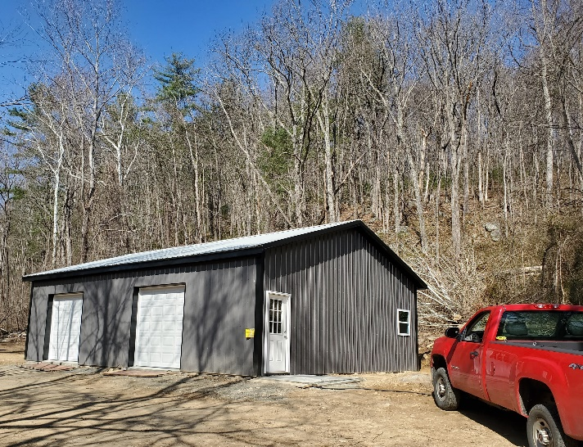
The Quonset hut, which served as a shop and maintenance area has been leaking and threatening to collapse for several years. Last fall and winter we were able to replace it with a beautiful new pole barn type building. The building has 2 big garage doors, a human sized door, a few windows for sunlight and a concrete floor. After some challenges getting the electric service installed we received our Certificate of Occupancy early in 2022. Mike Reed, our resident caretaker, was thrilled and immediately began building work benches built out of lumber milled from the trees that needed to be cleared for the new structure and moving tools and equipment into the new shop. What a difference it makes to have an enclosed space for equipment, and a dry, well lit space to work on maintenance projects!
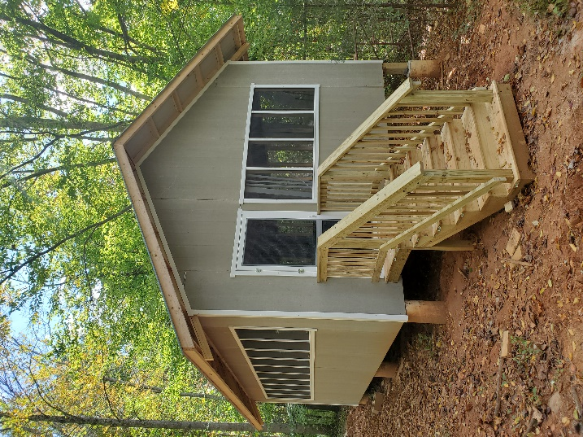
We have replaced 6 of the 10 camper cabins at Shiloh and we now have funding to replace the last 4. We hope to enter into an agreement with a contractor to build all 4 buildings: 2 in the spring of 2023 and 2 more in the fall. Unfortunately, contractors in the area are very busy right now and we have not yet been able to find a contractor to do the job within our budget. We will keep working on it and trust that way will open.
The water supply has run low from time to time at Shiloh and a new well site has been identified and permits have been issued. We are on the well drilling company's schedule and look forward to seeing the new well go into service before the summer of 2023.

In the years to come
We look forward to building a covered deck in front of the Health Center at Shiloh that will help expand the treatment area and provide more space for campers who are not feeling well inside the building. If funds can be secured we would like to complete this work for the summer of 2023.
Ruby's cabin, the cabin that the director stays in, is a historic log cabin that is quite old. It has received some loving care in the past but it is time for a new round of repairs and improvements. We look forward to planning these repairs in the year to come, seeking funding for the work and beginning the repairs in the years to come.

A new truck
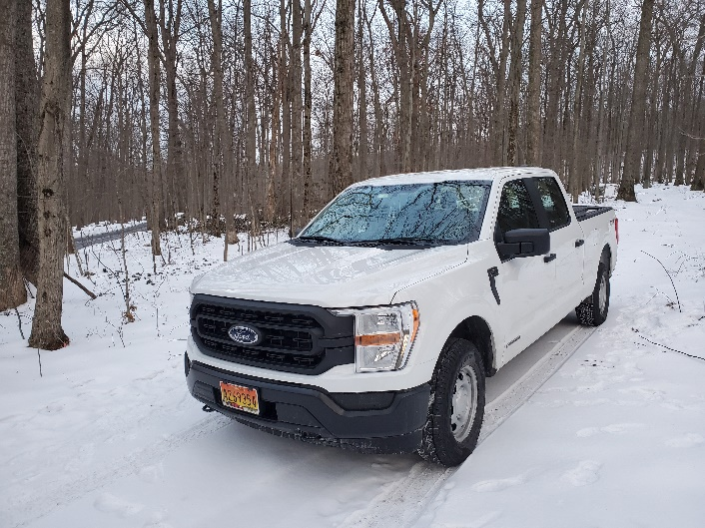
As friends might imagine, there is a lot of driving involved in the care and maintenance of 3 residential camps in 2 different states. The Camp Property Manager often needs to drive more than 20,000 miles in a year. In 2021 friends were asked to contribute towards purchase of a new hybrid truck in the hopes of reducing our carbon footprint and providing more reliable transportation that did not need a lot of costly repairs. Friends responded and nearly half of the cost of this truck was raised through the generosity of Friends. We received the new truck in February of 2022 and it has been performing admirably ever since. As our Camp Property Manager ages he is more and more appreciative of a reliable vehicle that drives a little more easily and that performs as designed. It is also a load off my mind to know that we have a fuel efficient vehicle that will not need a lot of repairs for many years to come. Thank you all for your kind and generous support of your Camp Property Manager and the camping programs!

The Camp Property Management Committee
The Camping Property Management Committee continues to strive to provide safe and welcoming spaces for our wonderful camping programs. This year, besides our regular work of budgeting, planning work days to maintain the properties, planning major improvements, etc., the committee has engaged in gaged in several additional projects.
At the prompting of the BYM Reparation Action Working Group we have considered how we can best respond to past injustices which have been perpetrated on the properties we now steward. We have given serious consideration to sending land rent to the native peoples whose land we occupy as well as other ways we might address injustices of the past and present. These funds would be generated by adding a surcharge to rentals fee for off-season rentals at the camps. The Camping Program might also choose to add a surcharge to camp fees to be used in the same way. We have been in touch with the leadership of the Piscataway tribe which once occupied the land at Catoctin and this relationship shows a great deal of promise. We continue to research and reach out to the tribal governments of native people who most recently occupied our properties in Virginia.
The committee has also engaged in a site assessments process at Catoctin and Shiloh. This research will eventually lead to a more detailed long range plans for major repairs and improvements on each of these sites.

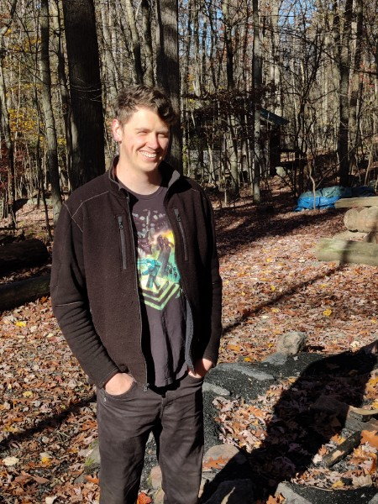
Caretakers
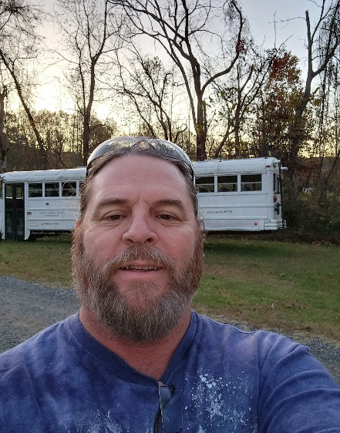
Both our wonderful caretakers are thriving in their positions! Dylan Phillips at Catoctin is an exceptional host for our AirBnB and HipCamp guests. He has also become an integral part of the summer camp community in ways that other caretakers have found challenging and he is doing an awesome job of coordinating and supporting projects and contractors at the camp.
Mike Reed continues to take wonderful care of Shiloh. It is rare to find a branch across a path or the grass un-mowed at Shiloh. Mike has also played an important role in coordinating work with contractors and getting proposals for new projects over the last year. All this while he and his wife are welcoming a new teenager into their home! A remarkable family indeed! We wish you all the best for your new family.
Change happens but the heart of the camps endure. Our camps properties are first and foremost the hearts and homes for our amazing camping programs. They are also sanctuaries for the beauty and sacredness of the natural world and all who have the chance to be present in these place feel a sense of gratitude to the organization and the individuals that make the conservation of these places possible. Thank you all for supporting and sustaining these precious places!
With deep gratitude,

David Hunter
Camp Property Manager
Baltimore Yearly Meeting

